**Universidad de Costa Rica Escuela de**

# Centroamericana Geología

**Texas A&M University**

# Soltis Center for Research and Education





**Proyecto:**

## Geología del Soltis Center for Research and Education y alrededores

**Javier Oviedo González**

**A74739**

**2013**

## GENERAL INDEX

GENERAL INDEX1 INDEX OF FIGURES4 PHOTO INDEX5

3D6 MODEL INDEX INDEX OF TABLES6 INTRODUCTION7

1. INTRODUCTION8
   1. OBJECTIVES8
      1. General Objective8
      2. Specific Objectives8

1.2 METHODOLOGY9

* 1. ACKNOWLEDGEMENTS10
  2. GEOGRAPHICAL FRAMEWORK10
     1. Location of the area10
     2. Area Accessibility12 GEOLOGY13

1. REGIONAL GEOLOGICAL FRAMEWORK15
   1. Monteverde Training15
   2. Quaternary Epiclastic Rocks and Sediments16
2. LOCAL GEOLOGY19
   1. Andean Basalt Waterfall Unit (Q1-ct) 21
      1. Location21
      2. Lithology and other characteristics21
      3. Age23
      4. Origin24
   2. Toba Crab Unit (Q12-cj) 25
      1. Location25
      2. Lithology and other characteristics25
      3. Age26
      4. Origin26
   3. Chachaguita Gap Unit (Q12-cg) 27
      1. Location27
      2. Lithology and other characteristics27
      3. Age28
      4. Origin28
   4. Chachagua Alluvial Deposits Unit (Q2-ch) 29
      1. Location29
      2. Description29
      3. Age and thickness30
      4. Origin30
   5. San Isidro Quaternary Deposits Unit (Q2-si) 31
      1. Location31
      2. Description31
      3. Age and thickness31
      4. Origin31 STRUCTURAL GEOLOGY32
3. STRUCTURAL GEOLOGY34

4 1. Faults34

* + 1. Regional34
    2. Observed35
    3. Inferred36

1. 2. Diaclasas36

GEOMORPHOLOGY38

1. GEOMORPHOLOGY40
2. 1. Regional Geomorphology40
   * 1. River Canyon40
     2. Ravine41
     3. Flow 41
     4. Sliding41
     5. Denudational hills42
     6. Foothills42

5.2. Local geomorphology44 HIDROGEOLOGY49

1. HYDROGEOLOGY50
   1. Aquifers50
   2. Drainage pattern51
   3. Born61
   4. Rivers and streams64 GEOLOGICAL HISTORY66
2. GEOLOGICAL HISTORY67

FINAL CONSIDERATIONS 68

1. CONCLUSIONS69
2. REMARKS70
3. RECOMMENDATIONS71
4. REFERENCES72 GLOSSARY74 ANNEXES77

PETROGRAPHIC ANALYSIS77 PHOTOGRAPHS89

3D102 MODELS

METHODOLOGY AND CONCEPTS104

## INDEX OF FIGURES

Figure 1. Map of the location of the area under study11 Figure 2. Regional stratigraphic column17

Figure 3. Regional geological map18 Figure 4. Local stratigraphic column19

Figure 5. Local geological map and geological profile20

Figure 6. Stereographic and pink tilt projection of the diaclases at the *knick point*

superior to the Cataract 36

Figure 7. Map of regional faults near the Soltis Center37 Figure 8. Regional geomorphological map43

Figure 9. Slope map of the area under study45

Figure 10. Diagram of the *knick points* observed at the Waterfall, Soltis Center47 Figure 11. Channel hierarchy map in the area under study53

Figure 12. Graph of average length vs. hierarchy of channels (semi-logarithmic scale). Figure 13. Graph of number of watercourses vs. hierarchy of watercourses.........................

Figure 14. Drainage frequency contour map of the area under study56 Figure 15. Pixel map of the drainage frequency of the area under study57 Figure 16. Drainage density contour map of the area under study58 Figure 17. Pixel map of the drainage density of the area under study58 Figure 18. Contour map of the drainage texture of the area under study59 Figure 19. Pixel map of the drainage texture of the area under study60

Figure 20. Proposed water table for the Soltis Center and surrounding areas63

Photo 1. *Knick point* quebrada Sin Nombre 1 89

Photograph 2. Lower *Knick point* broken Unnamed 2 90

Photograph 3. Upper *Knick point* broken Unnamed 2 91

Photo 4. Lower *Knick point in the* Catarata92 river Photo 5. Detail of the lower part of the Waterfall93

Photo 6. Detail of the upper part of the Waterfall 93

Photo 7. Upper *Knick point of the* Catarata94 river

Picture 8. Detail of the columns in the upper *knick point of the* Catarata River95 Photo 9. Detail of the left bank of the Catarata River at the upper *knick* point95

Photo 10. Detail of the niche and the diaclasas on the left bank of the Catarata River in the

*knick point* superior96

Photo 11. Cut in the path before arriving to the waterfall, detail of the slabs96 Photo 12. Slabs formed at the upper *knick point of the* Catarata River (right bank).

97

Photo 13. Slabs formed at the base of the upper *knick point of the* Catarata River (right bank) 97

Photo 14. Gap formed by the lahars in a tributary to the Catarata River (left bank) 2598 Photo 15. Gap formed by lahars in a tributary to the Catarata River (right bank) 98

Photo 16. Tributary to the Catarata River (point 27), note the gap on both banks of the river99

Photo 17. Chachagua River, right bank. 99

Photograph 18. Toba, point 25. 100

Photograph 19. Spring on Soltis Center property, item 28. 101

Photo 20. Spring at the end of the Tomas de Agua path, point ..........................................

21101

Model 1. Digital elevation model made with Surfer software, version 9.0 Refer to the symbolism in figure 1 102

Model 2. Digital elevation model, color scale every 50 m102 Model 3. Model of earrings, refer to the legend in Figure 9103

Model 4. Model of the geomorphological units, refer to the legend in Figure 8. 103

## TABLE INDEX

Table 1. Radiometric data near the study area24

Table 2. Area covered by slope ranges for the area under study46

Table 3. Description of the *knick points* observed in the area under study47 Table 4. Characteristics of Aquifers, Powerhouse51

Table 5. Analysis of the hierarchy of channels in the area under study54

## INTRODUCTION

This paper presents the results obtained during the field work at the Soltis Center for Research and Education and surroundings, at January and February 2013, for the course Práctica Geológica of the Escuela de Geología of the Universidad de Costa Rica. This course is intended to introduce the student into the professional work of geologists, letting it deal with real life problems.

The mayor goal of this research was to determinate the relationship between the geological features with the hydrogeology, geomorphology and tectonics features, inside the property of the Soltis Center and surroundings. With this in mind, several field trips were realized, taking into account of the lithology and other characteristics, like morphologies, shears/faults, etc. The coordinates of the outcrops and specific features observed in the field were annotated for future analysis.

The study area is found at San Isidro de Peñas Blancas, district of San Ramon in the province of Alajuela. Since the property of the Soltis Center is 250 acres, the decision to include other zones was taken, with the purpose to obtain a wide view of the geological aspects. So, at the end the study area was 6 km2, extending to the East of the Soltis Center.

Because of where the Soltis Center is located has no towns or reference points, local names or important features were used as referent points, like the waterfall, the tower, the frog pond and the parking lot, translated into the spanish as Catarata, Torre, Ranario and Parqueo, respectively. Other names were proposed, the first one refer to the Chachagua Rain Forest and Hacienda Hotel (named as Hotel at the figure 1), located at the northeast of the Soltis Center and the second one is Cangrejera, used for the local people to refer a section of the river Chachagua where fishing was common.

## INTRODUCTION

The present report corresponds to the results obtained in the project "Geology of the Soltis Center for Research and Education and surroundings" that was carried out for the Geological Practice course (G-4116), given by the School of Geology of the University of Costa Rica; this course intends to introduce the student to the professional practice of the geologist in the working field.

This professional practice was carried out during the months of January and February of this year in the property of the Soltis Center, headquarters in Costa Rica of Texas A&M University and in the surrounding lands.

In the following chapters the reader is introduced to the first arrangements made during the data collection in the field, then the analyses and interpretations made. Finally, some conclusions and recommendations on the results obtained are presented.

## OBJECTIVES

### General Objective

* + - * Determine the relationships of geological features with hydrogeology, geomorphology, and tectonics, within the Soltis Center property, as well as in the surrounding areas.

### Specific Objectives

* + - * Define the lithological units that are present in the area under study.
      * To interpret the geoforms observed in the area under study.
      * Denotes some hydrogeological aspects present in the area.

## 1.2 METHODOLOGY

A series of visits were made to the field, where trails and ravines were walked within the Soltis Center property, as well as in surrounding areas. In the outcrops found, the location was taken with a GPS model Map 60CSx Garmin brand, then a general description of the outcrop was made noting dimensions, degree of weathering, color of the rock and some other distinctive feature to be observed. If tectonic features such as faults, diaclases or rock inclinations were present, the direction and inclination were measured with a Krantz compass. The hand samples collected were analyzed under the magnifying glass (10X, 20X and 30X magnification) and the measurements made on the observed minerals were made with a Neiko Vernier, with a degree of uncertainty of 0.03 mm. The photographs of the outcrops visited were taken with a Kodak camera of 8.2 megapixels and a CANON SX30IS camera of 14 megapixels, while the microphotographs were taken with an Olympus Q Color microscope and camera, with a resolution of 2,560 x 1,920 megapixels and were edited with the QCapture Pro 6.0 program.

With the data collected from each outcrop, some interpretations were considered in order to understand the geological processes that gave rise to and transformed the area under study.

During the laboratory work, six petrographic sections were analyzed in order to detail the lithology present in the area under study. In addition, topographic maps of the area and aerial photographs (1992) were analyzed in order to identify the morphologies present in the area under study, so that this interpretation would also be useful for understanding the geology of the area. The previous procedure was carried out using as a guide the standards established by the *International Institute for Geo-Information Science and Earth Observation (*ITC) and the "*Aerial photo interpretation in terrains analysis and geomorphologic mapping*" (Van Zoidan, 1975).

Hydrogeological aspects were identified during field visits, describing watercourses, springs and wells, so that they could be related to the geology and geomorphology of the area.

## ACKNOWLEDGEMENTS

We express our gratitude to God for providing us with the health and protection to do this work and for helping us to make it happen. We also thank our families for giving us their support and helping us in everything, since without them it would not have been possible to finish this project. To Mr. Eugenio Gonzalez for allowing us to do our professional practice at the Soltis Center, to the cooks who always made sure we ate well, to the administrative staff for making sure everything was at our disposal and to the security guards for caring about our well-being and providing us with pleasant conversations. We are grateful to A&M University professors Chris Houser, Matthew Hammer, Rick Giardino and their wives, as well as professors from other careers who allowed us to enjoy their company during field trips. We are also grateful to Robert West, a professor at East Los Angeles College, who accompanied us to the field and gave us some insights into the geological and geomorphological aspects observed. Finally, I am grateful to Harold Johnson who was kind enough to review the English text and make some comments.

## GEOGRAPHICAL FRAMEWORK

### Location of the area

The project was carried out on the property of the Soltis Center for research and Education and in the surrounding areas. This center is located in San Isidro de Peñas Blancas, San Ramón, Alajuela, Costa Rica. The area under study corresponds to approximately three square kilometers, of which the Soltis Center owns 250 acres.

According to the cartography elaborated by the National Geographic Institute of Costa Rica, the area under study is located in the Fortuna Topographic Sheet, scale 1:50

000. Important geographical reference points include Cerro Chato, Arenal Volcano, Chachagua Creek, Chachaguita Creek, Cocoritos Lagoon, and Peñas Blancas River. The location of the area under study is shown in Figure 1, along with the outcrops and points visited.

**Glossary**

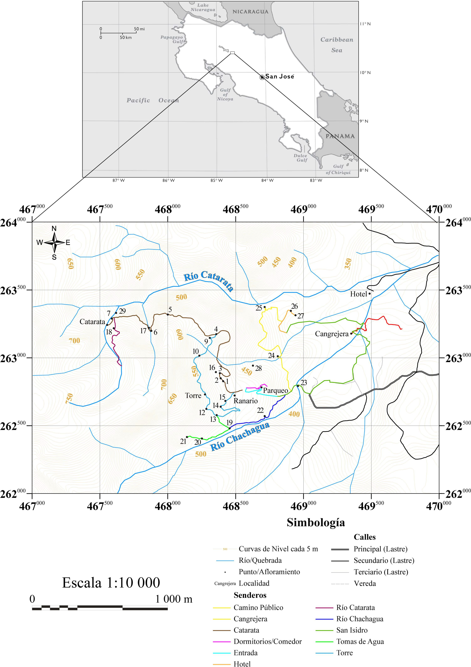**Figure 1. Map of the location of the area under study.**

### Accessibility of the area

The Soltis Center for Research and Education is accessible from the Juan Santamaría Airport by taking the General Cañas Highway (Interamerican Highway, Route 1), passing in front of the National Liquor Factory and the detours to Grecia, Naranjo and Palmares. When passing the city of Palmares, five kilometers later, you take the entrance to the city of San Ramon. In the city of San Ramon continue on the road north for 1.5 km, then turn left on Avenue 11 for 500 m and turn right on Route 702, towards the Fortuna de San Carlos. On this route you will go through the towns of Los Angeles, Bajo de los Rodriguez, La Tigra, until you reach San Isidro de Peñas Blancas. In Peñas Blancas, turn left after the cemetery and continue on a ballast road for 5 km until you reach the Soltis Center. Due to the conditions of the road it is difficult to move around in low vehicles. Access to the outcrops is on foot from the Soltis Center, taking the trails on the property and surrounding land, as well as the streams that run through the area.

## GEOLOGY

This abstract embraces two chapters, the regional and the local geology of the study area. The first one is based on a bibliographic research, where two units are defined for the zone and the second one shows the results of the field work, where five informal units were created.

Reconnaissance geologic mapping 1:50 000 close proximity of the Texas A&M University Soltis Center for Research and Education, San Isidro, Costa Rica by Alvarado (2009) distinguished lava flows with andesitic to basaltic composition (i.e, Monteverde Formation) and breccias, tuffs and laterite soils (grouped on an unit called Rocks and Epiclastic Sediments of Quaternary).

The goal of this project is to refine the previous mapping by breaking out five additional mappable units for an improved geologic interpretation. The Basaltic Andesite Catarata Unit (Q1-ct) found at western part of the study area, the lithology correspond to andesites and basaltic andesites and in petrographic thin sections these minerals are present (listed in order of abundance): plagioclase, augite, olivine hypersthene, pyrite. A pilotaxitic texture present in sample "SC-1" suggests the lava had a constant and not episodic flow. Some special features present in this unit are: “Lajas” (local term used for layered lavas) found at the waterfall and several joints reassembling to column joints at the top of the waterfall. The age for this unit is included inside Monteverde Formation age (2,1 to 1,1 My) and since the nearest radiometric dating is 1,79 ± 0,04 My, this paper considers this one for future reference.

The Cangrejera Tuff Unit (Q12-cj) located to the northeast of the Soltis Center, is a tuff with centimeter clasts in a sand-silty matrix. Unweathered appearance of this is unit is gray-beige. In a few localities the tuff was alter by the hydrothermal activity, to pale gray color and abundant neo-mineralization of pyrite.

The Chachaguita Breccias Unit (Q12-cg) identified in the northern river and creeks as poorly consolidated unit with mostly of decimeter and metric clasts within a mud-sandy matrix.

Aluvial Deposits Chachagua Unit (Q2-ch) is a generic named for all the alluvial deposits left by the rivers and creeks within the study area. Quaternary Deposits San Isidro

(Q2-si) correspond to unconsolidated colluvial deposits and soils, produced by the erosion and transportation of environmental agents during the Holocene until nowadays.

Monteverde Formation (therefore Basaltic Andesite Catarata Unit) is attributed to the largest fissure volcanism of Costa Rica. The Cangrejera Tuff Unit corresponds to an explosive volcanism but there are not enough evidence to determinate the exact location of source. The origin of Chachaguita Breccias Unit is explain by lahares occurred during the Late Pleistocene and Early Holocene. The two final units (as was said) are currently developed by erosion/transportation/sedimentation agents, as water, wind, etc. and later transform into soils by the deep weatherization existent in the zone.

## REGIONAL GEOLOGICAL SETTING

The regional geological framework is made up of volcanic rocks (andesites and basaltic andesites) and volcaniclastic rocks, which were reworked mainly by the action of water. The formation attributable to the volcanic rocks is the Monteverde Formation, while the volcaniclastic rocks were grouped under the unit designated as Quaternary Epiclastic Rocks and Sediments. Figure 2 shows the regional stratigraphic column and figure 3 shows the regional geological map.

### Monteverde Formation

The Monteverde Formation was initially described by Chaves and Saenz in 1974, however at the regional level there are other denominations, such as the works of Ramirez (1973), Mora (1977) and Aiazzi *et al* (2004) who refer to the more distant extension of this formation as Tierras Morenas lavas, Las Pulgas lavas and Cerro las Nubes lavas.

Lithologically, they correspond to basaltic to andesitic lavas, with a platform shape (*plateau)* (Aiazzi *et al,* 2004; Alvarado, 2009). Petrographically, basalts are described as aphanitic porphyritic with calcium plagioclase phenocrystals, augite and iddyngitized olivine (Mora, 1977); andesites are the predominant lithology of the Monteverde Formation, these are characterized by a dark gray color, with aphanitic porphyritic texture, composed of plagioclase phenocrystals and pyroxenes (Vargas, 2001; Žáček *et al,* 2012). In addition, crystals of olivine (partially or totally serpentine), magnetite and apatite can be found, as well as fluid structures within the matrix (Žáček *et al,* 2012). Some authors also include other lithologies, such as tuffs and breccias, which are found as intercalations between lavas (Madrigal, 2004; Žáček *et al,* 2012), however this is not well defined, therefore further studies are required.

The Monteverde Formation is discordantly overlying the Avocado Formation, whose contacts are difficult to observe; the main characteristics to differentiate both formations are of petrographic and geomorphological type (Vargas, 2001; Madrigal, 2004; Alvarado & Gans, 2012; Žáček et *al,*

2012). In the area under study, it is undergoing the Quaternary Epiclastic Rocks and Sediments. The best outcrops near the study area are found on the roads leading to the Peñas Blancas and Poco Sol Hydroelectric Projects, as well as the Poco Sol lagoon (Alvarado, 2009).

The Monteverde Formation corresponds to the largest physical activity of the Lower Quaternary and andesitic shields (Gillot *et al,* 1994; Alvarado, 2009; Alvarado & Gans, 2012), covering an area of 1 200 km2 and a volume of 400±100 km3 (Gillot et al, 1994); according to the geological profiles of the Miramar topographic sheet it is deduced that it has a thickness of 500 m (Žáček et al*,* 2012), however the thickness for the zone under study has not been defined.

Morphological and chronological evidence suggests that eruptive activity in the area has progressively migrated north of the caldera Poco Sol, towards the hills of Los Perdidos, then to Cerro Chato, and now to the Arenal Volcano (Gillot *et al,* 1994). The age of the

Monteverde Formation corresponds to a range of 2.1 - 1.1 Ma (Alvarado, 2009; Alvarado & Gans, 2012).

### Quaternary Epiclastic Rocks and Sediments

This unit is not associated with any established formation, Madrigal *et al* (1995) are the first to mention epiclastic deposits in the area corresponding to the Peñas Blancas Hydroelectric Project. For this section, the name designated by Alvarado (2009) has been used, which generally describes a series of deposits with similar characteristics; however, the lithology that emerges in the area under study is called "Lateritized piedmont deposits" (Alvarado, 2009) (see figure 3).

These deposits lithologically correspond mostly to a thick breccia, with angular clasts, ranging in diameter from decimeters to metrics. Grain contact varies from punctual to floating in the matrix. The matrix normally presents brown clays as a result of weathering and presents different degrees of hydrothermal alteration. Because several deposition mechanisms are identified within this unit, the texture described above may vary. Locally these

Deposits may present interstratification with tufa and lavas, which are superficially altered to reddish and brown-orange soils (lateritized), constituting the foothills of the eastern end of the Tilarán mountain range (Vargas, 2001).

The deposition mechanisms inferred from the different lithofacies are: mass removal (slides of various dimensions) and *debris flow* (alluviums and lahars). According to the granulometry and morphometry of this unit, it is inferred that the transport distances from the origin of the flow are short. There is a unit with a maximum thickness of about 70 m of epiclastic deposits, originated by the volcanic-sedimentary removal of the formation described in the previous section (Vargas, 2001).

The age of this unit is certainly later than the Monteverde Formation, due to the presence of clasts that are correlated with the lithology of this formation. By means of the hydrothermal fossil alteration found in some parts, it is presumed that the age is prior to the Holocene (Vargas, 2001).

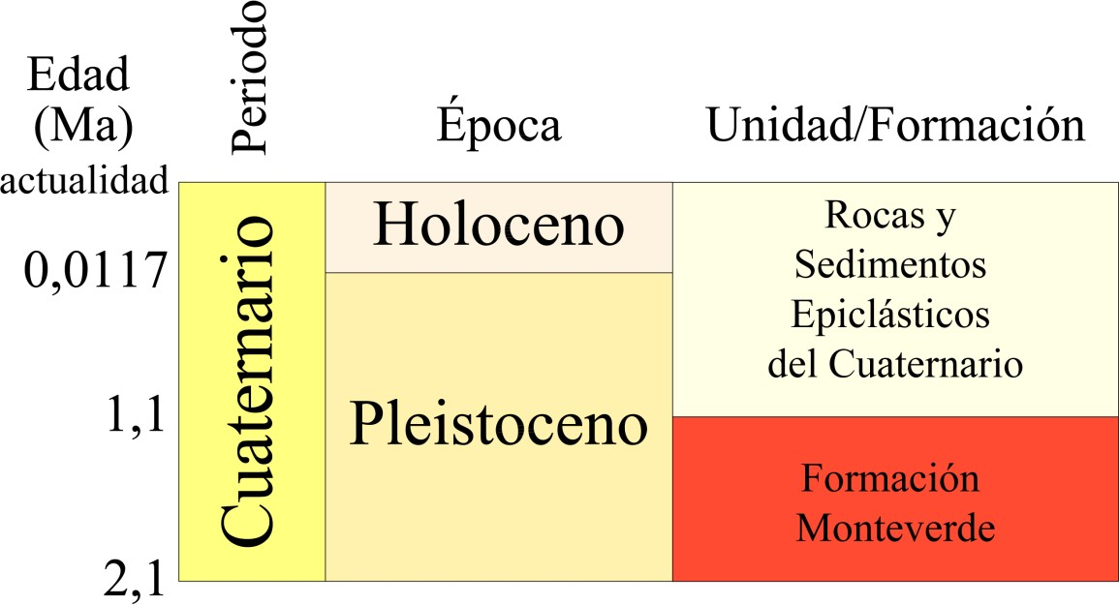

### Figure 2. Regional stratigraphic column.

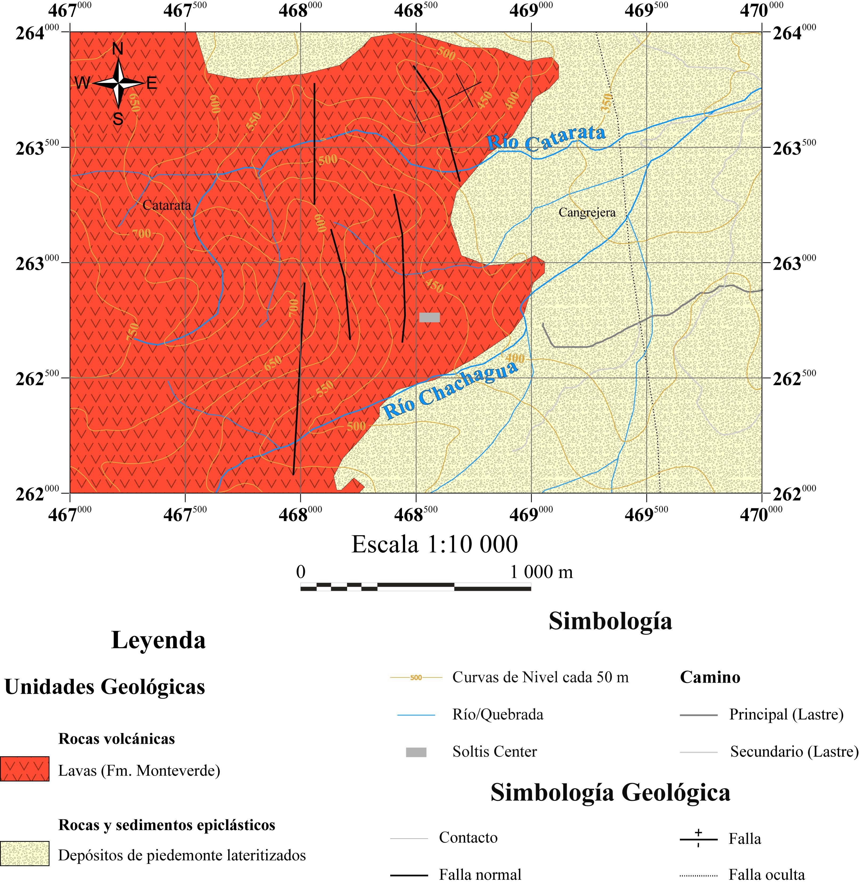

**Glossary**

**Figure 3. Regional geological map.**

**Modified from Alvarado, 2009*.***

**Glossary**

1. **LOCAL GEOLOGY**

The following are the lithological units established for the area under study, according to data obtained from field visits and petrographic analyses performed on the samples collected. A total of five informal units were defined: Catarata Andean Basalt Unit, Chachaguita Breccia Unit, Tobas Cangrejera Unit, Chachagua Alluvial Deposits Unit and San Isidro Quaternary Deposits Unit. Figure 4 shows the local stratigraphic column and figure 5 presents the local geological map for the area under study

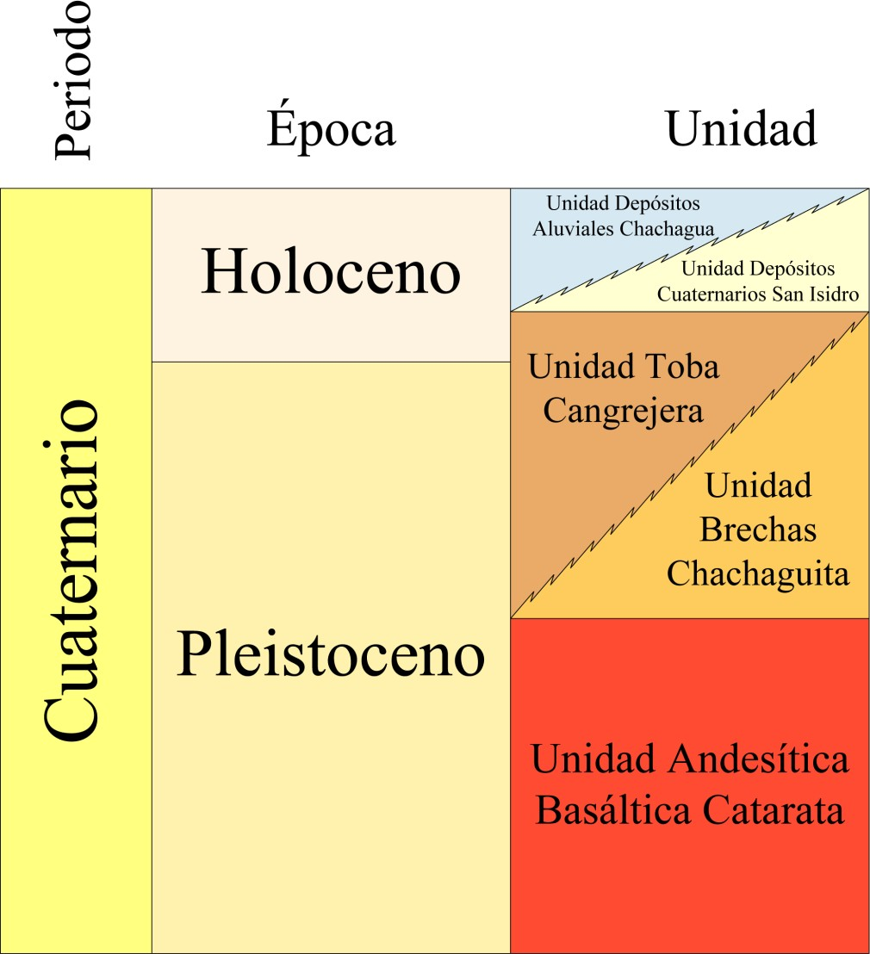

### Figure 4. Local stratigraphic column.

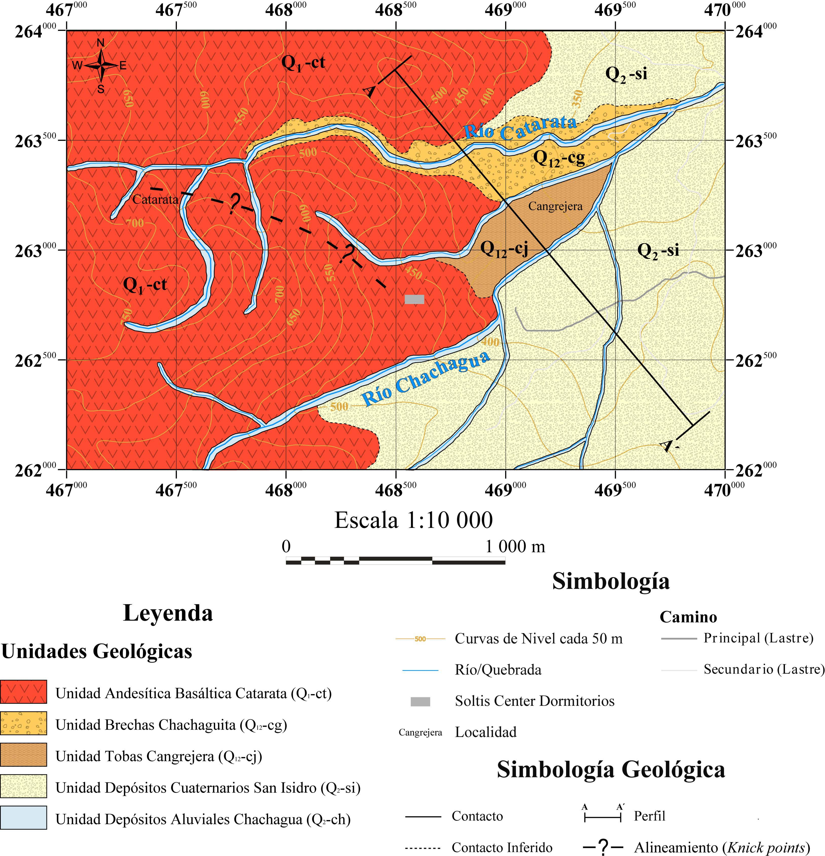

**Glossary**

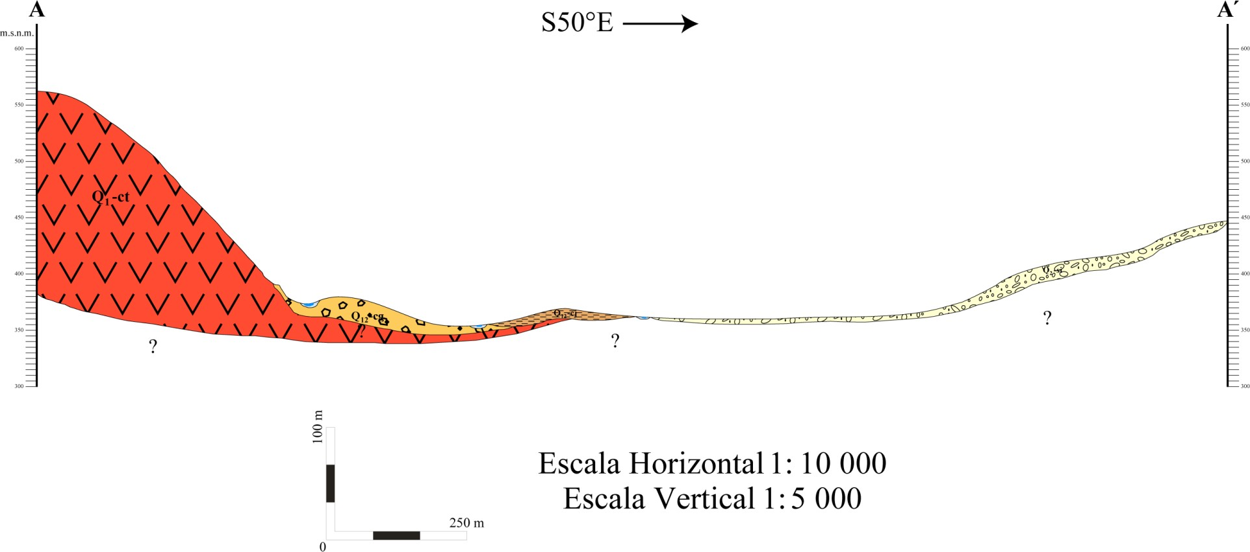

**Figure 5. Local geological map and geological profile.**

* 1. **Andean Basalt Waterfall Unit (Q1-ct)**

The following is a description of the informal unit designated as the Chachagua Andean Basalt Unit, which was defined according to the lithologies observed in the field. This unit is dispersed throughout the western sector of the area under study and corresponds to the stratigraphic base of the area's geology. It is formally described in the geological literature as the Monteverde Formation.

### Location

It is found outlining the entire western sector of the map (see figure 5). The locality and type outcrop is located at the waterfall within the Soltis Center property (point Waterfall i n figure 1), whose coordinates are : 263 246 N - 467 554 W. The dimensions of the outcrop are as follows: 24 m high by 12 m wide.

Other outcrops that show this unit correspond to cuts in trails, water sources, *knick points* and river and stream banks. Most of these are altered by weather conditions in the area and by the effect of vegetation on the rock, especially in the cuts in the trails, however good outcrops can be found in the creeks and rivers that cross the property.

### Lithology and other characteristics

The rocks belonging to this unit are classified as andesites to basaltic andesites, the latter denomination due to the presence of olivine. The lithology is described below according to the degree of weathering in the rocks observed.

The healthiest rocks have a dark grey colour, with an aphanitic porphyritic texture, the plagioclases are observed with the naked eye with millimetric sizes, the matrix is intense grey, which prevents the recognition of other minerals at a macroscopic level. The samples collected with these characteristics are located in the Cataract (see description of section SC-1 in the Petrographic Analysis annex).

The rocks with an intermediate degree of weathering are located at the *knick points,* springs and some sectors of the trails. They present a lighter shade of gray and a considerable decrease in the size of the plagioclases, but they are observed in greater quantity compared to the previous description, partly due to the clayization that occurs to them, which facilitates their recognition. Pyroxenes of millimetric size are also observed, this because of the greater color contrast with the matrix. Finally, the samples collected show a patina that can be up to one centimeter thick (see description of section SC-2 and CL-1 in the Petrographic Analysis annex).

Finally, that lithology with an advanced degree of meteorization exhibits an even lighter shade of gray than the previous case, the plagioclases are not recognized in macroscopy, it is only possible to identify pyroxene crystals. When the degree of meteorization is very advanced, what is observed is a rock in transition to soil, beige-white in color, with the silhouette of oxidized crystals (see description of section SC-3 in the Petrographic Analysis annex).

Microscopically the only constant mineral is plagioclase, found in rocks with the three degrees of weathering mentioned above. Other minerals that were determined (ordered from the healthiest to the most meteorized samples) are the following: olivine and opaque crystals (sample SC-1); augite crystals,

hypersten and opaque (sample CL-1); haematite-altered augite ghosts (sample SC-3).

There are two special features within this unit to highlight, the first to treat is the slabs observed in points 7 and Cataract (see photos 11, 12 and 13). In Costa Rican geological terminology, a slab is defined as a rock of volcanic origin that has a laminated shape with smooth surfaces, which usually end abruptly in a wedge shape. This structure is formed by the constant flow of lava.

In point 7 the thickness of the slabs covers a range between 20 cm and 4 cm, the modal value being 5 cm. The lava flow direction in this section is N35°E, with an inclination of 18°1. The thickness of this section of the trail is approximately 3 m.

In the highest part of the lower *knick point of the* waterfall (see section 5.2. and photographs 4 and 6) there is a lajeado and diaclasado aspect, as opposed to the basal part which is totally massive (see photographs 4 and 5); this makes one think that this part of the waterfall corresponds to the section of the trail that was discussed in the previous paragraph, this determined from the inclination of the slabs.

At the beginning of the upper *knick point of* the Cataract (see section 5.2. and photograph 12) the maximum thickness of the slabs is 20 cm and the minimum is 6 cm, while the fashion is 6 cm. The direction of flow is N20°W with 16° inclination1.

The second important characteristic is the presence of structures similar to cooling columns, at the upper *knick point of* the Cataract. These structures with a vertical orientation, smooth surfaces and wedge-shaped termination that reach the top of the *knick point,* seem to present incipient features of flowering structures. The origin is due to a rapid cooling that causes tension in the rock, until a point is reached where the rock fragments, forming the fractures that are currently observed (see photographs 7 and 8).

As mentioned in the introduction to this section, this unit corresponds to the stratigraphic base, and therefore functions as the basis for the lithologies mentioned below. The thickness corresponds to the difference in maximum and minimum altitude where this unit appears, therefore it is approximately 380 m.

### Age

The age assigned to this unit corresponds to the age for the Monteverde Formation, which is located in the Lower-Middle Pleistocene. According to the compilation of absolute ages for the i g n e o u s and metamorphic rocks of Costa Rica made by

1 The directions and inclination presented could be affected by the technonism of the area, therefore the original lava flow could have different directions and inclinations.

Alvarado & Gans (2012), there are four radiometric data close to the area under study, which are shown in Table 1.

### Table 1. Radiometric data near the area under study.

**Taken from Alvarado & Gans, 2012.**

|  |  |  |  |
| --- | --- | --- | --- |
| Sample | Lithology | Location | Age (Ma) |
| CR-104 | Andesite  basalt | Peñas Blancas Hydroelectric Project,  260 950 N/470 025 W | 1,79 ± 0,04  (40Ar/39Ar: mtz) |
| CR-107 | Andesite  basalt | Peñas Blancas Hydroelectric Project,  260 950 N/ 470 025 W | 1,79 ± 0,004  (40Ar/39Ar: mtz) |
| G-49 Y | K-rich andesite | 500 m NW Poco Sol lagoon, 258 900 N/462 300 W | 1,313 ± 0,04  1,282 ± 0,04  (K/Ar: mtz) |
| G-49 Z | Aluminum Basalt | For San Miguel de Poco Sol, 259 900 N/466 400 W | 1,313 ± 0,04  1,282 ± 0,04  (K/Ar: mtz) |

* + 1. **Source**

It is due to effusive igneous activity, which caused lava flows from the west of the area under study.

## Toba Crab Unit (Q12-cj)

Below is the description of the informal unit designated as Toba Crab Unit, which was defined according to the lithologies observed in the field. This unit is associated with the Quaternary Epiclastic Rocks and Sediments.

### Location

It is located northeast of the Soltis Center, in the quadrant bounded by the following coordinates north: 262 500 - 263 500 and the following coordinates west: 468 500 - 469

500. The name of the unit is derived from the designation by the locals of a section of a tributary to the Chachagua River and is known as Cangrejera. The standard outcrop located in this section of the creek has the following coordinates: 263 183 N - 469 354 W (Cangrejera point in Figure 1).

### Lithology and other characteristics

The general appearance of the lithology is massive and consists of clasts of different types of rock floating in a sandy-loamy matrix, with the presence of some minerals unrecognizable by weathering and alteration to clays, in addition the matrix presents vesicles of size less than a millimeter, distributed abundantly.

The selection of the clasts is bad, because the sizes are varied, being the fashion of 2x1,5 cm, although the greater sizes can reach dimensions of 12x10 cm and the smaller 1 mm of diameter, equally these do not show any preferential disposition in relation to their size, but that are distributed randomly. The composition as mentioned above is varied, defined by the different colors observed (beige, light gray, pink, etc.), however the degree of weathering that is high, prevents a detailed classification. The rock is classified as tufa (see photograph 18).

An important aspect to highlight is the colour of the lithology, as this changes considerably depending on the factors that acted on it. In the case of the weathered tufa (point 24 in figure 1) it corresponds to a grey-pink tone, while in

La Cangrejera has a uniform light grey colour along the whole outcrop, due to the hydrothermal alteration that has occurred in this area.

This hydrothermal alteration also produced other changes besides the color, since the tufa is more consolidated, reason why it is more difficult to detach a fragment. Another change that occurred was the pyritization, in which tiny pyrite crystals are observed, disseminated in certain surfaces at the moment of extracting the rock; therefore they are not disseminated in the matrix, but these surfaces were zones of weakness (fractures, cavities, etc.) through which the liquids ascended and when they cooled down the mineralization occurred.

Microscopically in La Cangrejera, secondary quartz, olivine and pyrite crystals are determined in a glass matrix, however the rock is very altered and what is most observed is a gray-white paste (see description of section CAN-1 in the Petrographic Analysis annex). The minimum thickness observed is approximately 2.5 m, both in point 24 and in the Crab in figure 1.

### Age

Since there are no dates for this lithology, the age assigned corresponds to the formal unit to which it is associated, described in Alvarado (2009) as Quaternary Epiclastic Rocks and Sediments; therefore the Toba Cangrejera Unit is located in the Quaternary, although these deposits probably began to be expelled at the beginning of this period.

### Source

The genesis of these deposits corresponds to high density flows (known as ignimbrites), expelled during the volcanism that originated the Monteverde Formation. Later, the extensive hydrothermal activity that the area presented in the past, produced the pyrite mineralization observed in La Cangrejera. Finally, the deposits were affected by external agents that erased their presence in some sectors, while in others they modified their appearance and characteristics.

## Chachaguita Gap Unit (Q12-cg)

The following is a description of the informal unit designated as the Chachaguita Gap Unit, which was defined according to the lithologies observed in the field. This unit is associated with Quaternary Epiclastic Rocks and Sediments.

### Location

This unit forms the bed and banks of rivers and streams in the northeastern sector of the area under study. The name of this unit comes from the Chachaguita Creek, located to the north of the area under study (because there is no nearby locality or creek with a name). The typical locality is the (unnamed) creek that runs through the Chachagua Rainforest Hotel & Hacienda (point 25 in Figure 1); good outcrops are located at points 26 and 27 (see Figure 1), which are equivalent to the following coordinates: 263 351 N - 468 909 W and 263 318 N - 468 943 W respectively.

### Lithology and other characteristics

The textural classification of the observed lithology is consistent with a brecciated conglomerate, due to the fact that spherical to elliptical rounded clasts are observed. The granulometry is varied and therefore the selection is poor. The larger clasts are about 40 cm in the longest axis, while the smaller ones have a diameter of 3.5 mm. The general appearance is massive, with a moderate degree of consolidation, although the matrix is extremely crumbly. The blocks, edges and pebbles of primarily andesitic composition, are distributed chaotically floating in a sandy matrix of gray color, however when this is meteorized (most recurrent case) changes to shades of brown and beige, product of the oxidation of minerals (see photographs 14 and 15).

In the route made in the above-mentioned ravine, some small *knick points* were appreciated, ranging from 50 cm to 2 m in height. These are probably due to the erosion of the water, without a

aspect of tectonic origin, as explained below for the *knick points* observed in the Andean Basaltic Cataract Unit.

The deposit has a minimum thickness of approximately 3.5 m, observed on the margins of the creek (see photograph 16).

### Age

The age corresponds to the Quaternary (Alvarado, 2009), however, more exact data can be obtained from finding fossil remains carried along by the surrounding lithological deposits (which were not observed) to which the radio-carbon technique 14 can be applied.

### Source

The origin of this lithology is due to lahars that flowed through rivers and streams. These consist of water flows that remove fragments of the pre-existing rocks, which during transport are shaped by friction, thus giving the rounded shapes of the blocks and edges observed. When the phenomenon ceased, the blocks and edges were deposited within the mud matrix with water that accompanied them, which, when this last element was lost, consolidated, allowing the preservation of the sediments transported by the lahar.

## Chachagua Alluvial Deposits Unit (Q2-ch)

Below is the description of the informal unit designated as the Chachagua Alluvial Deposits Unit, which was defined according to the lithologies observed in the field.

### Location

This unit is located along the rivers and streams that are in the area under study (see Figure 5). The type locality outcrops on the Chachagua River (see photo 17). The distribution of the deposits is according to the length of the riverbed.

### Description

They correspond to an accumulation of edges on the bottoms and edges of the riverbeds. The edges have rounded to subrounded shapes and the sphericity can vary throughout its range, the size varies according to the channel from centimeter to metric, however in no case is reached to exceed 10 m on the long axis. The colors can vary due to the petrographic characteristics as well as the degree of meteorization of each edge, however the gray color predominates in its different tonalities.

The composition of the edges is homogeneous due to the fact that the lithology of the source area is the same (see section 3.1), however, small variations may occur at the petrographic level as mentioned above (see description of section RC-1 in the annex Petrographic Analysis). Along the same lines, it should be mentioned that a textural variation is observed between the samples collected in the Chachagua River and those collected on the Soltis Center property, since although they all correspond to basaltic andesites, those concerning this section present plagioclases in greater quantity, of larger sizes (maximum 5.7x4.65 mm, 7.51x5.62 mm and 6.57x1.82 mm); minimum 2.96x1.45 mm, 1.81x1.3 mm and 1.96x1.24 mm) and with rounded shapes.

This can be explained by two factors that are acting simultaneously, the first of which is that the lava flows from which the

Samples from both the Chachagua River and the Soltis Center are totally different and each casting was formed under different conditions, which explains the difference in abundance and size of the plagioclases. The second factor is that the samples from the Chachagua River, being in constant contact with water, make the plagioclases hydrate and increase their size, hence the difference in shape and again in size.

### Age and thickness

He is assigned a Quaternary age with contributions up to the present day. The accumulated thickness of the edges is inconsistent even in the same riverbed, so if a hydrogeological study is carried out in a specific section of the river or stream, it is recommended that it be measured for that section.

### Source

The origin is due to the erosive action of the environmental agents that detach rock fragments that are transported to the beds, as well as to the bed itself that drags the edges and molds them.

## San Isidro Quaternary Deposits Unit (Q2-si)

The following is a description of the informal unit designated as the San Isidro Quaternary Deposit Unit, which was defined according to the lithologies observed in the field.

### Location

This unit is distributed throughout the eastern part of the area under study (see Figure 5).

### Description

It is made up of reddish and brown-orange lateritized soils, together with colluvial deposits.

### Age and thickness

He's assigned a Quaternary age. The thickness may vary depending on the site, because the environmental agents acting in the area do so differently depending on the lithology they affect.

### Source

The origin is due to the erosive action of environmental agents (such as water, wind, etc.) that modify the lithology already present. It is also due to the deposition of sediments carried by rivers and streams.

## STRUCTURAL GEOLOGY

This chapter covers two structural features: faults and joints. The first feature is subdivided into three kinds of faults: regional faults, observed faults and an inferred fault. The joints were observed at the top of the waterfall, where three families of joints were determined.

To have a wider view of tectonic control where the study area is located, was decided to remark about the nearest major faults of the zone, according to a bibliographic research. The first fault is called Chachaguita and is located to the northeast of the Soltis Center. It is a lineament with SW-NE direction, which follows Chachaguita creek. It is considered as a normal fault, the hanging wall corresponds to the SE block.

The Peñas Blancas fault receives his name from the river which goes along this lineament. The main direction is NW-SE and, it is possible to recognize it even on satellite images. At the field it presents scarps of hundreds of meters, which allow interpreting it as a normal fault where the NW block (footwall) is below the opposite one.

The Jabillos fault is considered by some authors as a continuation of Peñas Blancas fault, because it direction is very similar and they are almost juxtaposed; besides of those here is mention as a different fault. It is found southward of San Isidro town; it has an ENE- WSW direction, with a normal component where the south block corresponds to the hanging wall. According to empiric equations, was possible to determine a 6,3 maximum magnitude in case this fault might produce an earthquake.

Finally according to the regional geological map, the zone shows two major lineaments that cross the study area: one of them is an inferred fault and the other one is a hidden fault. Inside the study area there are three lineaments, for one of them was possible to determine a normal component. All of these structures present a N-S direction, but there is not description about them in the paper attached to the map.

Two observed fault were measured at the Soltis Center property, situated 100 meters downstream of the waterfall. These lineaments are in the Basaltic Andesite Catarata Unit, they present a S30°W and Ef direction, forming a 60° between them that indicates they are conjugated pair of faults. No kinematic indicators were found that allow checking the movement of these faults.

The inferred fault is a hypothesis to explain the lineament of the knick points observed at the Soltis Center property, which presents a SE-NW direction. This hypothesis requires more studies to check it or discard it.

The joints where found on the left margin of the Catarata River, at the superior knick point of the waterfall. The detachment of the rock produced by the joints was forming smooth planes that were measured. Also because of the detachment and the erosion of the water, at this point was forming an abrasion notch (see photographyies 9 and 10).

## STRUCTURAL GEOLOGY

The following description covers the tectonic structures in the area under study, which correspond to inferred (see Figure 5), observed and regional faults (see Figure 7), along with a series of diaclases observed at the Cataract. The stereographic projection and the inclination rose of the diaclases was made in the Tectonics FP *software* version 1.76.

### Faults

The following three sections describe the faults found in the area under study, which were subdivided into regional faults, described on the basis of the bibliographical information consulted; observed faults, which were determined in the field work; and finally inferred faults, deduced from the presence of morpho-neotectonic features, such as the *knick points described in the* following chapter.

### Regional

According to Vargas (2001), there are three main faults near the Soltis Center, known as Chachaguita, Peñas Blancas and Jabillos (ordered from the closest to the furthest). It should be clarified that there are certain authors who take the Peñas Blancas fault as a continuation of the Jabillos fault (Madrigal *et al*, 1995; Alvarado, 2009), because they present a similar direction and are almost juxtaposed.

The Chachaguita fault (see Figure 7) is located northwest of the Soltis Center and has a SW-NE direction. It is a 6 km long alignment that runs along the Chachaguita Creek. It is inferred that it is a normal fault with the SE block raised with respect to the NW block and that it has a strong inclination towards the northwest (Vargas, 2001). The Peñas Blancas fault (see Figure 7) runs along the river of the same name, is approximately 20 km long and heads SW-NE. It is possible to recognize it even in satellite images, while in the field the task is made even easier by the presence of escarpments in the Peñas Blancas River of up to several hectares, which allow us to deduce that it is a normal fault where the

lowered block is NW with respect to the

The opposite, however, taking into account the regional pattern of compressive stresses, is expected to also present a course displacement component (Vargas, 2001).

The Jabillos fault (see figure 7) is located south of San Isidro de Peñas Blancas, running almost parallel to the street that connects the entrance of this town with the town of Jabillos. This fault is an ENE-WSW-bound alignment, with a normal component, where the S block has been raised with respect to the N block (Vargas, 2001). According to Madrigal *et al* (1995), the association of the Peñas Blancas and Jabillos faults has a length of 15 km and a depth of 5 km. In addition, the maximum magnitude expected from an earthquake on this fault is 6.3, based on empirical formulas that take into account the characteristics mentioned above.

Finally, within the area under study, the geological map of the Fortuna sheet (Alvarado, 2009) shows a series of faults with an N-S direction; for one of these a vertical component was determined (see Figure 7), however, in the map description no mention is made of these alignments.

### Observed

Two alignments were observed northwest of the Soltis Center, specifically in the rocks at the bottom of the Catarata River bed, approximately 100 m downstream of the Catarata. These alignments are affecting the Chachagua Andean Basaltic unit and, have a direction S30°W and Ef forming between them an angle of 60°, therefore it is inferred that it is a conjugated pair of faults, associated to the regional faults mentioned before. Since the size of the faults was very small, they are not presented in the geological map, and the movement of the faults is indeterminable until now, since no kinematic indicators were found to determine it.

### Inferred

According to the orientation of the *knick points* observed within the Soltis Center property (see section 5.2.), it follows that these correspond to an alignment with SE-NW direction (see figure 5). This alignment may correspond to a fault or the scarp of a fault, however this is only a hypothesis that requires further studies to verify.

### Diaclases

A series of diaclasas (see figure 6) were observed on the left bank of the Catarata River, specifically at the upper *knick point of the Catarata* (see section 5.2. and photograph 10). The diaclasas are present affecting the rocks of the Chachagua Andean Basaltic Unit and formed smooth planes when the rock was detached, therefore we proceeded to measure these planes. Detached rock blocks formed angular edges and accumulated at the base of the upper *knick point of the* Cataract, due to this detachment and water erosion a niche was being formed (see photographs 9 and 10). Below are the stereographic projections using the Wulf network and the tilt rose for the measured diaclase planes.

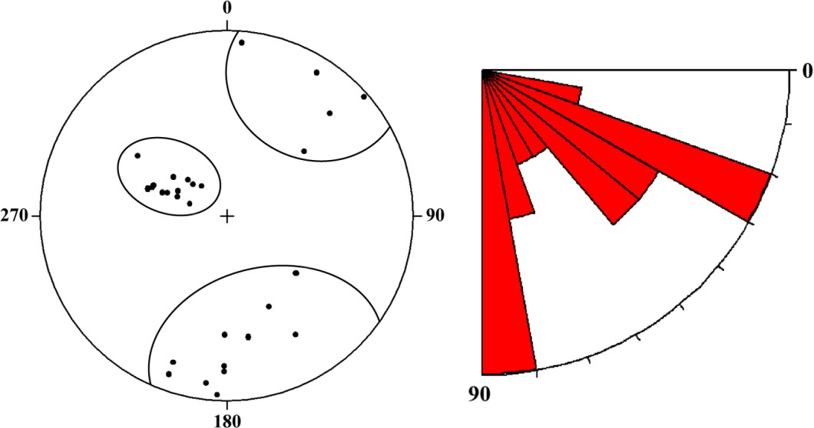

### Figure 6. Stereographic and pink tilt projection of the diaclasas at the upper *knick point of the* Cataract.

**Glossary**

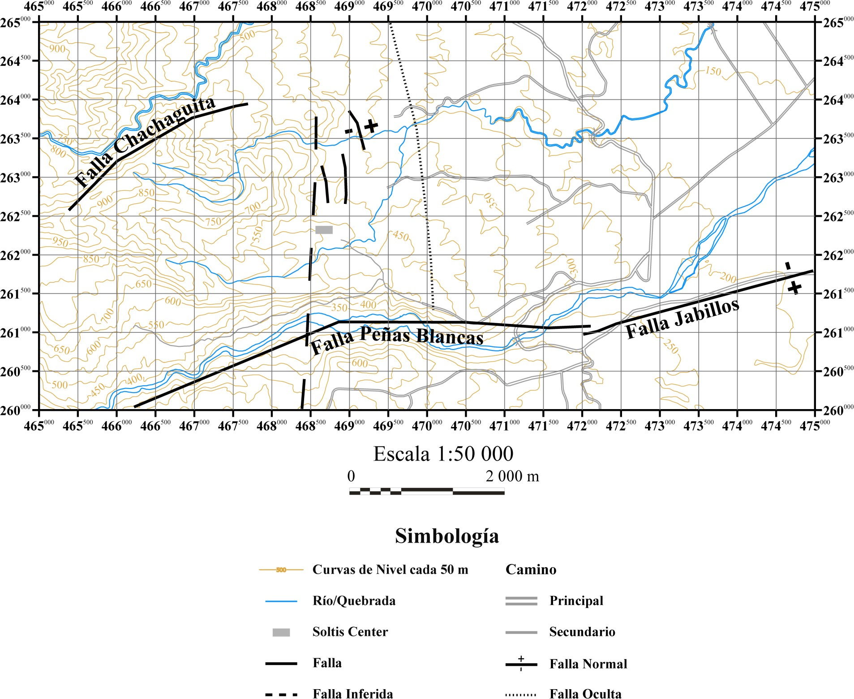

**Figure 7. Map of regional faults near the Soltis Center.**

**GEOMORPHOLOGY**

This chapter was divided in two main topics: regional and local geomorphology; the intention with this division was to show a wider view of the morphologies that surround the study area and then to focus on special features inside of the Soltis Center property and surroundings.

To the regional geomorphology the zone was extended from 6 km2 to 42,25 km2, in that area were observed six morphologies described below (see figure 8). The Peñas Blancas river is forming a canyon of an average 200 meters of deep with slopes of 40°. The Chachaguita creek is developing a gully with minimum and maximum deep of 80 m and 100 m respectively, the slopes on both margins present a difference, the left margin has homogenous slopes of 20° and the right margin has slopes within the range of 30°-40°.

On the right margin of the Peñas Blancas River there is a slump of 290 m2, comparing the satellite image and the aerial photography, this is an inactive slump. The Soltis Center is situated on denudational hills that have a highest elevation of 800 m.a.s.l. The slopes of this morphology are diverse, but the steepest slopes are found above the 530 m.a.s.l.

At the top of the denudational hills, there is a morphology called “Flow”, the origin of this flow might be a lava flow proceeding from the west, with a direction of ESE and then it has a slight rotation to the NE. The last morphology is the foothill located at the east, this comprehends the biggest area (32 km2) of the map and the slopes are in the range from 0 to 20°. The morphology is characterized for a wavy topography.

The local geomorphology includes there aspects: slumps, slopes and knick points. The slumps have a maximum area of 100 m2, with a rupture surface lower than 1 m deep. Because of the small area and the fact that they are covered with vegetation, it is impossible to locate the slumps on the map. The factors that influence the origin of these slumps are: the steep slopes and the intense weathering of the lithology.

The slopes on the mountain part of the study area are from 20° to approximately 50° steep. The 0 to 20° slopes are the most widespread and they are located on the east part. At the Catarata river the slopes are from 30° to 50° steep, which correspond to the observation made at the field.

Finally, because there are consecutive knick points on a same river or creek, was created a nomenclature to refer to them. The first knick point is located upstream and it is called “superior knick point”, the second is located downstream and it is named “inferior knick point” (see figure 10).

Consecutive knick points were found on the creek before the waterfall and the Catarata river, and another one on the first creek on the waterfall trial. All of these present certain lineament to the NW, which might indicate a tectonic structure, as was noticed on the structural geology chapter. Another knick point was found on the Catarata River, approximately 1 km downstream from the waterfall, this one presents a different height that might indicate that its origin is from a change of lithology.

## GEOMORPHOLOGY

This chapter covers the regional and local geomorphological description, taking into account field observations. The regional description is made with the delimitation of each geo-form, assigning it to an informal unit according to the standards established by the International Institute for Geo-Information Science and Earth Observation (ITC) and according to the "*Aerial* photo interpretation in terrains analysis and geomorphologic mapping" by Van Zoidan, (1975). The geomorphological map is presented in figure 8. The maps have as cartographic base the map of isolines of height (every 10 m), elaborated with the *software* Arcmap, version 10.0, scale 1:50 000.

### Regional Geomorphology

Because the area under study is quite limited, it was framed in a much larger area, so as to show the dynamics of the erosive and sedimentological processes, which affect the present geoforms. Five geomorphological units were delimited in the area proposed for the geomorphological analysis, which are described below and presented in the geomorphological map (see Figure 8).

### River Canyon

It is located in the southern sector of the geomorphological map, on the Peñas Blancas River and it is this that originates it. In the area observed, this morphology covers an area of 4.6 km2 and extends for approximately 7 km. The average depth is around 200 m, while the greatest depth slightly exceeds this value. The average slope is 40°, however this value can change significantly depending on the place observed. According to (Alvarado, 2009) the outcropping rocks on the slopes of the Peñas Blancas River correspond to the Avocado and Monteverde formations.

### Ravine

This morphology is of a lower order than the river canyon and is defined as such by the significantly smaller dimensions. It is located in the northern zone of the geomorphological map, along the Chachaguita Creek and extends for approximately 8 km and covers an area of 1.6 km2. The depths are around 80 and 100 m, the slopes on the left bank are quite homogeneous, with an angle of approximately 20°, while on the right bank they are around 30° to 40°. According to Alvarado's map (2009), the lithologies included in this geoform correspond to the Monteverde Formation and the Quaternary Rocks and Epiclastic Sediments.

### Flow

This is the name given to the geoform observed in the westernmost middle zone of the geomorphological map, which presents an appearance of gradual displacement. Therefore, when related to the geology of the zone in which it is found, it is interpreted as a lava flow that occurred during Pleistocene volcanism (Monteverde Formation). This morphology presents an area of 0.29 km2 with a slightly convex aspect and a movement towards the ESE for 600 m, with a small deviation towards the NE for 650 m. The slopes in the lateral and frontal zones are between 30° and 40°, while in the central zone the slope is around 20°.

### Slide

It is located on the right bank of the Peñas Blancas River, between the coordinates 260 770 - 261 450 N and 468 000 - 468 750 W. This morphology presents a displacement towards the north, with zones of slopes of 10°, 20° and 30°, where the average corresponds to 20°. The area it covers is approximately 0.29 km2.

By comparing the 1992 aerial photograph with the Google Earth satellite image of 2013, it can be deduced that this is a dormant slide, as at the oldest date the slide sector has no vegetation at all, while 21 years later the crown area and the middle area are populated with secondary forest.

### Denudational hills

They are located to the west of the geomorphological map and within this geomorph are included the Soltis Center property. They extend over 6.8 km2, with an altitude difference of around 450 m, the lowest level being 350 m. The slopes are varied, mostly observed areas between 10 ° and 30 °, however in the central area of the morphology, after the level 530 m above sea level there are sectors between 30 ° to 40 ° and a minimum fraction between 40 ° to 50 °. The origin is due to the effect of the erosive agents of the present lithology, which is related to the Monteverde Formation.

### Foothills

Three regions are defined on the geomorphological map as foothills: in the northern zone, east of the denudational hills and in the southeast corner. The area covered by each of the above regions is: 10.1 km2 , 20.3 km2 and 1.6 km2 , for a total of 32 km2 of this morphology. The slopes are very homogeneous, ranging from 0° to 20°, decreasing progressively as you move away from the mountains. This unit is moderately dissected and has a wavy topography. The lithology in which it is found corresponds to Quaternary Epiclastic Rocks and Sediments (Alvarado, 2009).

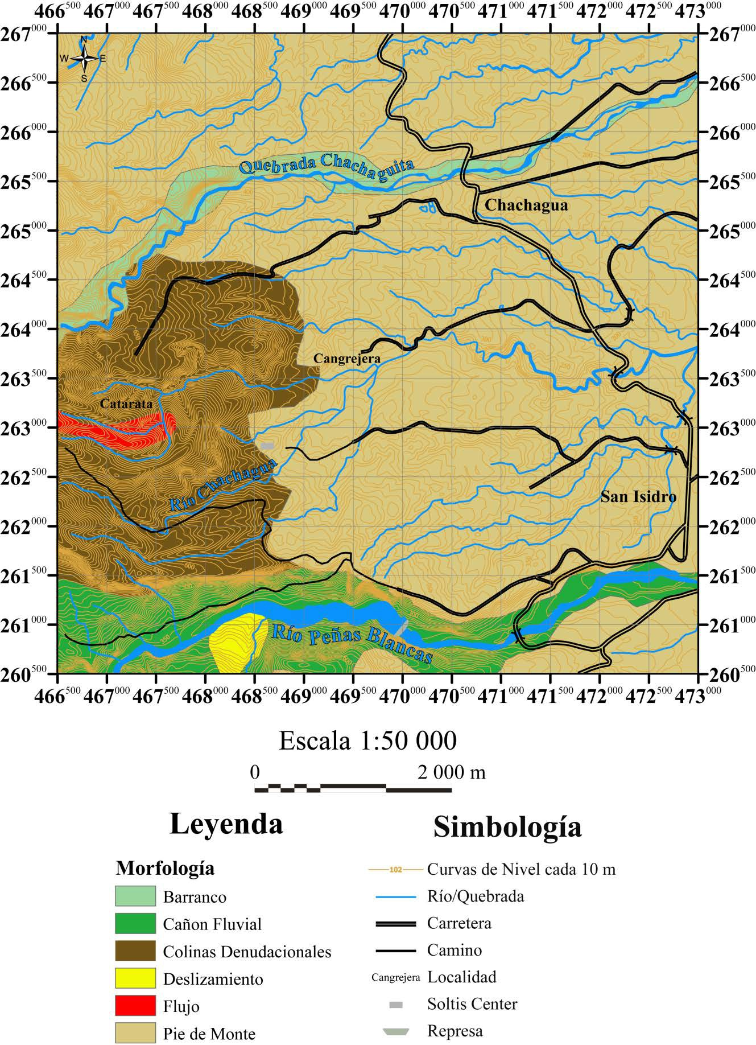

### Figure 8. Regional geomorphological map.

* 1. **Local geomorphology**

The following describes some of the most relevant morphologies observed in the vicinity of the Soltis Center, which have an intrinsic value when related to other aspects mentioned above.

During field visits, small slides were observed on the hillsides that make up the Soltis Center property. These landslides have a surface rupture of less than one meter, and their dimensions barely cover an area of no more than 100 m2. Adding that they are covered by vegetation, it is almost impossible to locate them on the maps or aerial photographs obtained for the area.

One of the reasons for the large number of these small slides is the type of substrate in which they occur, since this consists of highly eroded soils with little cohesion, resulting from the weathering of the lava that make up the lithology of the area (see section 3.1.2.); another cause is the steep slopes observed on the eastern slopes of the hills, a point that will be discussed below.

When you look at the topography on the location map (see figure 1) as well as when you go to the Soltis Center you can notice a quite radical change, since in the center of San Isidro the topography is quite flat, with few hills of soft slopes and little height until you reach the entrance of the Soltis Center, where the slope starts to get steeper and the height starts to increase rapidly. As you walk the trails, you can see how the slopes are even steeper. Figure 9 shows the slope map, classified in ranges of 10°. According to the results obtained, the steepest slope is approximately 50°. Finally, Table 2 presents the areas covered by the different ranges of slope.

**Glossary**

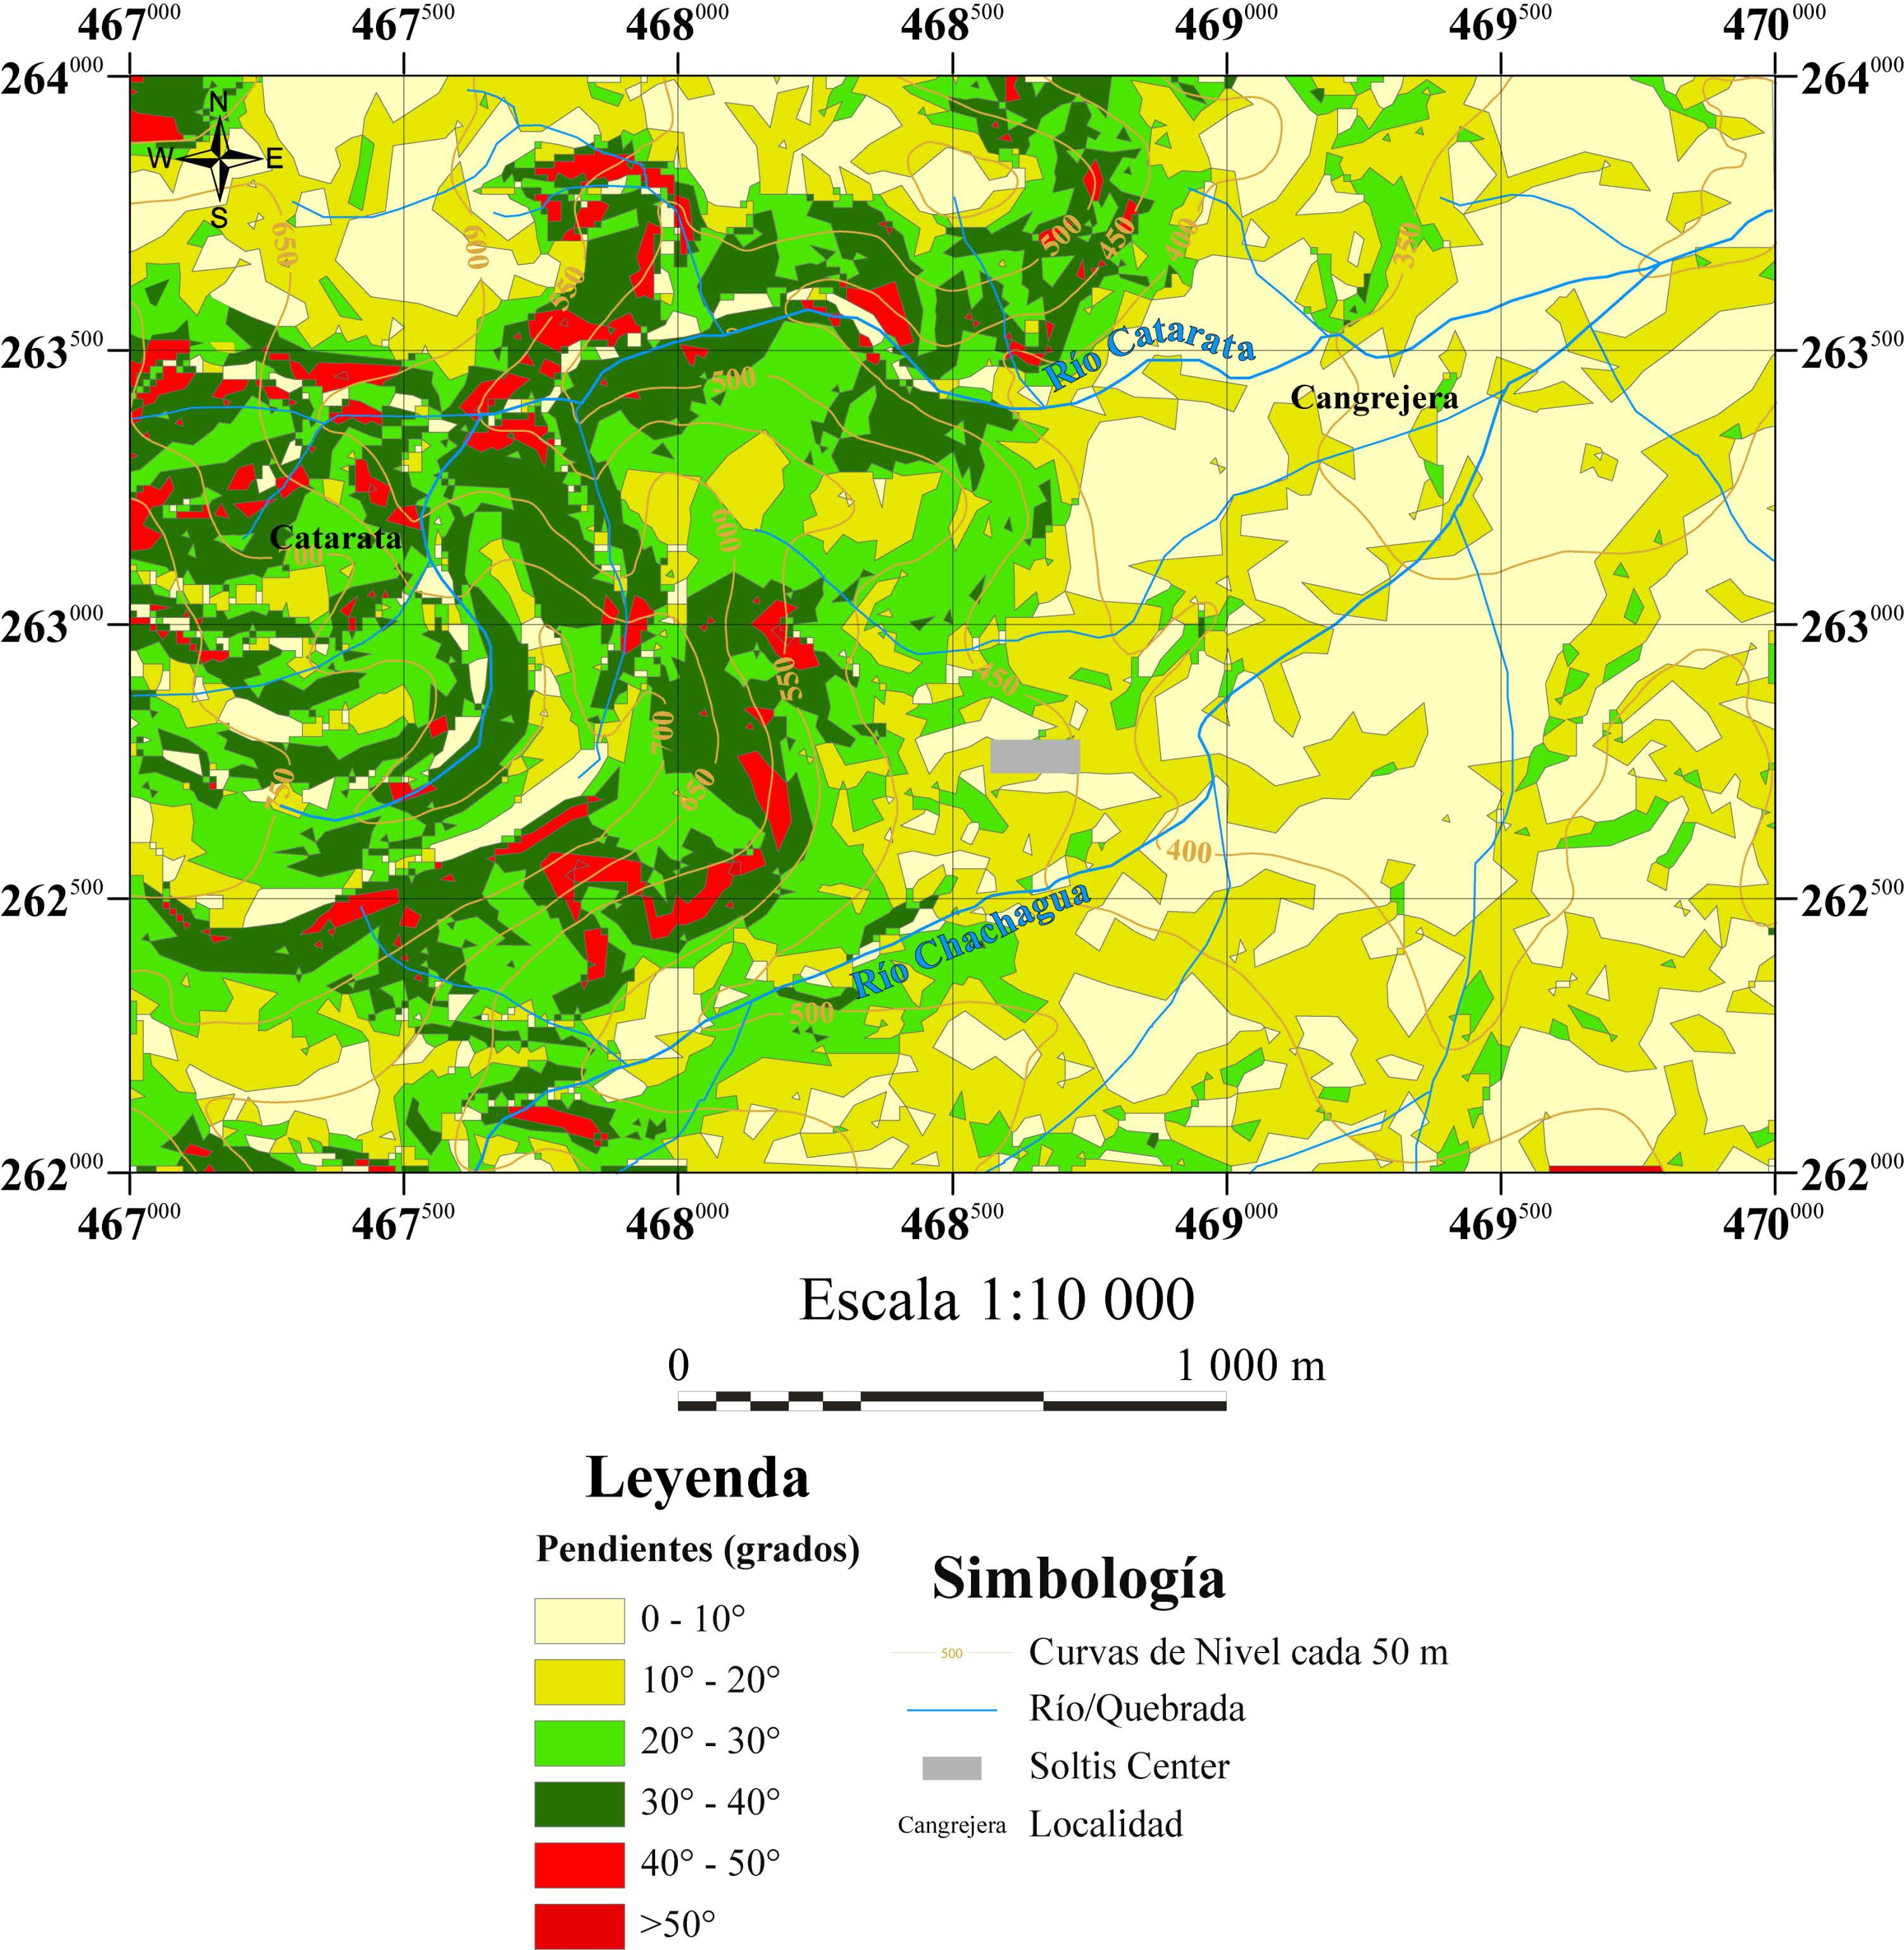

# Figure 9. Slope map of the area under study.

### Table 2. Area covered by slope ranges for the area under study.

|  |  |  |
| --- | --- | --- |
| **Slope range** | **Area covered (km2)** | **Area covered (ha)** |
| 0° – 10° | 1,9 | 192,0 |
| 10° – 20° | 1,7 | 170,7 |
| 20° – 30° | 1,2 | 124,1 |
| 30° – 40° | 0,9 | 89,2 |
| 40° – 50° | 0,1 | 15,6 |
| >50° | 0,004 | 0,5 |

The table above shows that the slopes between 0° and 20° are the most extensive in the area under study. However, on the Soltis Center property the slopes are around 20° to 40°, and there are small sectors with slopes greater than 40°. On the banks of the Catarata River, the slopes are in the range of 30° to 50°, which corresponds to the observations made in the field.

A last aspect to consider in this section are the various *knick points* present in the area under study (see photos 1, 2 and 3), which have a certain NW-SE alignment. A *knick point* can be defined as an abrupt change in the longitudinal equilibrium profile of a river (Lord *et al*, 2009). The most common cause of this change is due to regressive erosion of the river as a result of a drop in sea level. However, there are other reasons for this morphology, such as changes in lithology, tectonic control, etc.

Table 3 shows the information collected in the field work on the *knick points* observed on the Soltis Center property. In some cases these could be immediately in the same river or stream, so it is clear that the upstream knick *point is referred to as the* upper one, while the downstream one is referred to as the lower one (see Figure 10).

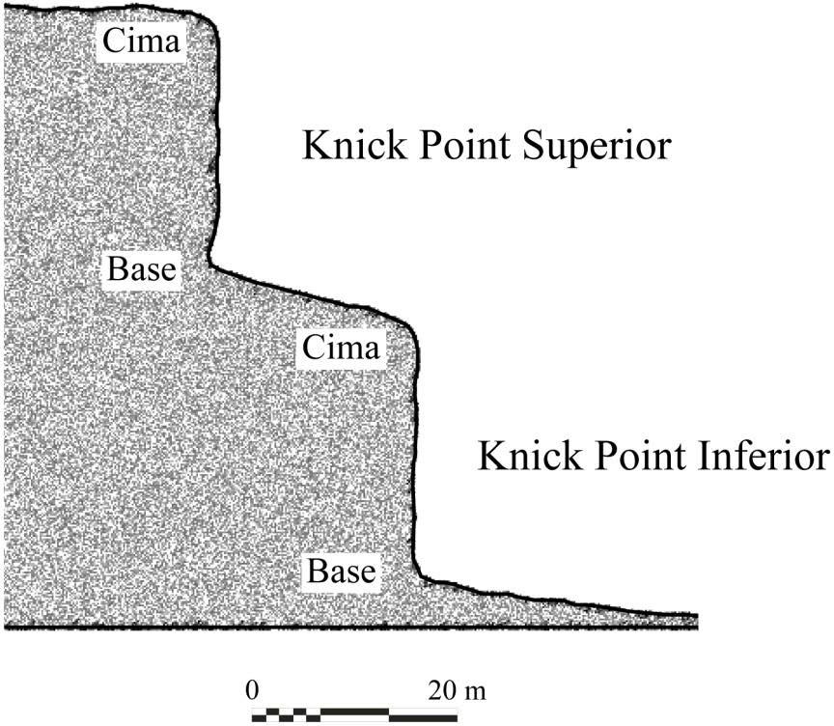

### Figure 10. Diagram of the *knick points* observed at the Waterfall, Soltis Center.

**Table 3. Description of the *knick points* observed in the area under study.**

|  |  |  |  |  |  |
| --- | --- | --- | --- | --- | --- |
| Coordinates | | | | | |
| Gorge | *Knick Point* |  | Altitude  (m.s.n.m.) | | Height (m) |
|  |  | North | West |  |  |
| No name 1 | – | 262 900 | 468 365 | 453 (Base) | 7 |
| No name 2 | Lower | 263 226 | 467 863 | 548 (Base) | 8 |
| Superior | 7 |
| Waterfall | Lower | 263 270 | 467 563 | 600 (Top) | 24 |
| Superior | 263 223 | 467 603 | 617 (Base) | 22 |
| Waterfall | – | 263 016 | 468 813 | 387 (Base) | 4 |

Note: Refer to Figure 10 for the base and peak terms.

The origin of the first five *knick poins may be* due to two causes, the first of which may be that they are due to different lava flows, expelled during early Pleistocene volcanism, so each one represents the most distant part of the lava flow; the second cause would be that the *knick points* come from a tectonic control in the area, so they would form a kind of escarpment. The last option is considered more accurate in the present work, since it takes into account the fault west of the Soltis Center that presents a similar direction to that of the *knick points and* also that some are separated by an intermediate zone between the upper and lower level, discarding the option that they are the end of different lava flows. Another aspect that supports the previous hypothesis is the similarity between the heights, both of the *knick points that are* located in the streams with no name 1 and 2, as well as in the same stream as in the lower and upper *knick points of* the Catarata River and the stream with no name 2. In a similar analysis carried out in the longitudinal profiles of the Grande de Tárcoles, Grande and Virilla rivers, Porras *et al* (2012) conclude that this type of structures in the above mentioned streams are of tectonic origin, which reinforces

the hypothesis that the *knick points* found in the Soltis Center are of tectonic origin.

Finally, the last *knick point is* very separated from the others, so it is not likely that its origin is the same; what seems to happen in this case is a change in lithology, since it was in this sector where the Toba La Cangrejera Unit was first found. Another aspect is that the height of the latter differs from the others, which supports the hypothesis that the genesis of this particular *knick point is* due to different causes than the others.

**HYDROGEOLOGY**

This chapter starts with a bibliographic research of the aquifers present at the zone. The nearest hydrogeological information comes from the Poco Sol Hydroelectric Proyect, where four aquifers were defined according to wells lithologies and pumping tests. The first one is an unconfined aquifer and then continues with a semiconfined aquifer, the two final aquifers are confined. The unconfined aquifer is the one can be correlated to the study area, where the water table is cropping out at many levels.

The drainage frequency map presents the number of rivers on 1/16 of km2, on this map there are two aspects to highlight: the first one is the Catarata River presents many tributaries and the second one is a gradual increase of river to the east part of the map. The second map is about density drainage, which it shows the length of the rivers present on 1/16 of km2. The major feature observed on the contour density drainage map is a lineament at the center, with direction NW, this might be to the change of topography from a mountain zone to a plain zone.

The longest rivers are situated on the Breccias Chachaguita and the Tuff Cangrejera units, probably because this lithologies are the most heterogeneous and unconsolidated ones. Contrary to the anterior sentence, the Basaltic Andesite Catarata Unit presents a scarce frequency and density drainage pattern, due to the low development of the rivers on this lithology.

Many springs were found at the Soltis Center property and surroundings, cropping out on the Basaltic Andesite Catarata Unit and the Breccias Chachaguita Unit. Most of the springs present a considerable caudal and that is a reason with they are used to provide of water to the community and the Soltis Center.

Finally the Soltis Center property is cross by many rivers and creeks, which present big boulders that, indicate the strength of the river when a flash flood happens. Another characteristic of the rivers and creeks is the clear water that they carry; this might indicate high quality water. The quality and quantity of the water are one reason why the Soltis Center presents a high biodiversity and, that is why it should be care.

## HYDROGEOLOGY

The hydrogeological information presented below was obtained from observation in the field of rivers, streams and headwaters, as well as from the bibliographical information collected on the aquifers in the area and the application of morphometric methods derived from the layout of the drainage system. With this one it is tried to discuss briefly the hydrogeological characteristics of the zone in which the Soltis Center is located, nevertheless to lack of precise data the following discussion is very general and what it looks for is to make aware the reader on the hydrogeological potential of the zone.

### Aquifers

The information on the aquifers closest to the area under study is located within the area of the Peñas Blancas Hydroelectric Project (PH) and is based on Vargas (2001). According to the study carried out for the powerhouse of this project, four aquifers were detected, of which one is free and the other three, defined as Upper, Intermediate and Lower, correspond to semi-confined the first and confined the last two (Vargas, 2001).

The free aquifer presents a relatively shallow phreatic level, since it is in contact with the soil with the lithology that underlies it. In the case of the Peñas Blancas PH machine house, this lithology corresponds to a breccia tufa (Vargas, 2001). The characteristics of the Upper, Intermediate and Lower aquifers are shown in Table 4, which were determined by the study of the observation wells, pumping tests and the analysis of these by the Jacob's methods (see annex Methodology and concepts: Jacob's method) (Vargas, 2001).

### Table 4. Characteristics of Aquifers, Powerhouse.

**Modified from Vargas, 2001.**

|  |  |  |  |  |  |  |
| --- | --- | --- | --- | --- | --- | --- |
| **Name of Aquifer** | **Floor- ceiling (m.s.n.m.)** | **Thickn ess (m)** | **Piezometric Level (m.s.n.m.)** | **Reservoir Lithology** | **Storage Coefficient** | **Transmissibility (m2/day)** |
| Superior | 150 – 178 | 24 – 28 | 190,89 – 192,38 | Megabrechts | 1,6x103 | 132,42 |
| Intermedia te | 135 – 150 | 15 | 194,27 – 196,17 | Megabrechts | 3,35x104 | 79,96 |
| Lower | ? - – 130 | ? | 197,38 | Megabrechts | - | - |

* 1. **Drainage pattern**

Because the area under study is too small to define a drainage pattern, the area of the geomorphological map is used as a reference (see figure 8). Through the distribution and arrangement of the riverbeds, two types of drainage patterns can be observed (one more defined than the other), which are influenced by the lithology in which they are found.

The drainage pattern located above the Colinas denudacionales unit is poorly developed and not very uniform. However, there are certain indications that it corresponds to a sub-dendritic pattern, such as a subtle parallelism in some of the watercourses and an increase in the slope of the land. In addition, the tectonic control mentioned above is consistent with the characteristics of sub-dendritic drainage.

The second pattern, located in the foothills geomorphological unit, is interpreted as a sub-parallel, where the riverbeds have a similar runoff direction, in this case towards the east, with slight deviations of 10° to 20° towards the south and north.

Specifically for the area under study, a quantitative analysis of the drainage pattern was carried out, following the Horton-Strahler classification methodology (see annex Methodology and concepts: Horton-Strahler method) for the hierarchization of the surface drainage network, which is summarized below:

* + 1. Channels that are the headwaters of the network are assigned the value 1.
    2. The conjunction of two channels of order 1, implies that the drainage network increases in magnitude so that from the place of confluence it is assigned the value 2.
    3. The meeting point between two channels of order 2 implies that the magnitude of the drainage network rises again, so the corresponding numerical value from there is 3.
    4. This is done successively until the drainage network is ranked.

According to the previous steps, the hierarchical hydrological map was obtained (see figure 11). The results obtained from the analysis of the number of watercourses and the length of each order are shown below. The length ratio [1] and the bifurcation ratio [2] are then calculated using these parameters, which are shown in the following equations (see Table 5).

R = Mo [1]

L

Mo-1

Where:

RL: Length Ratio

Mo: Accumulated length of order channels u.

R = Nu [2]

b

Nu+1

Where:

Rb: Length ratio

Nu: Number of order channels u.

**Glossary**

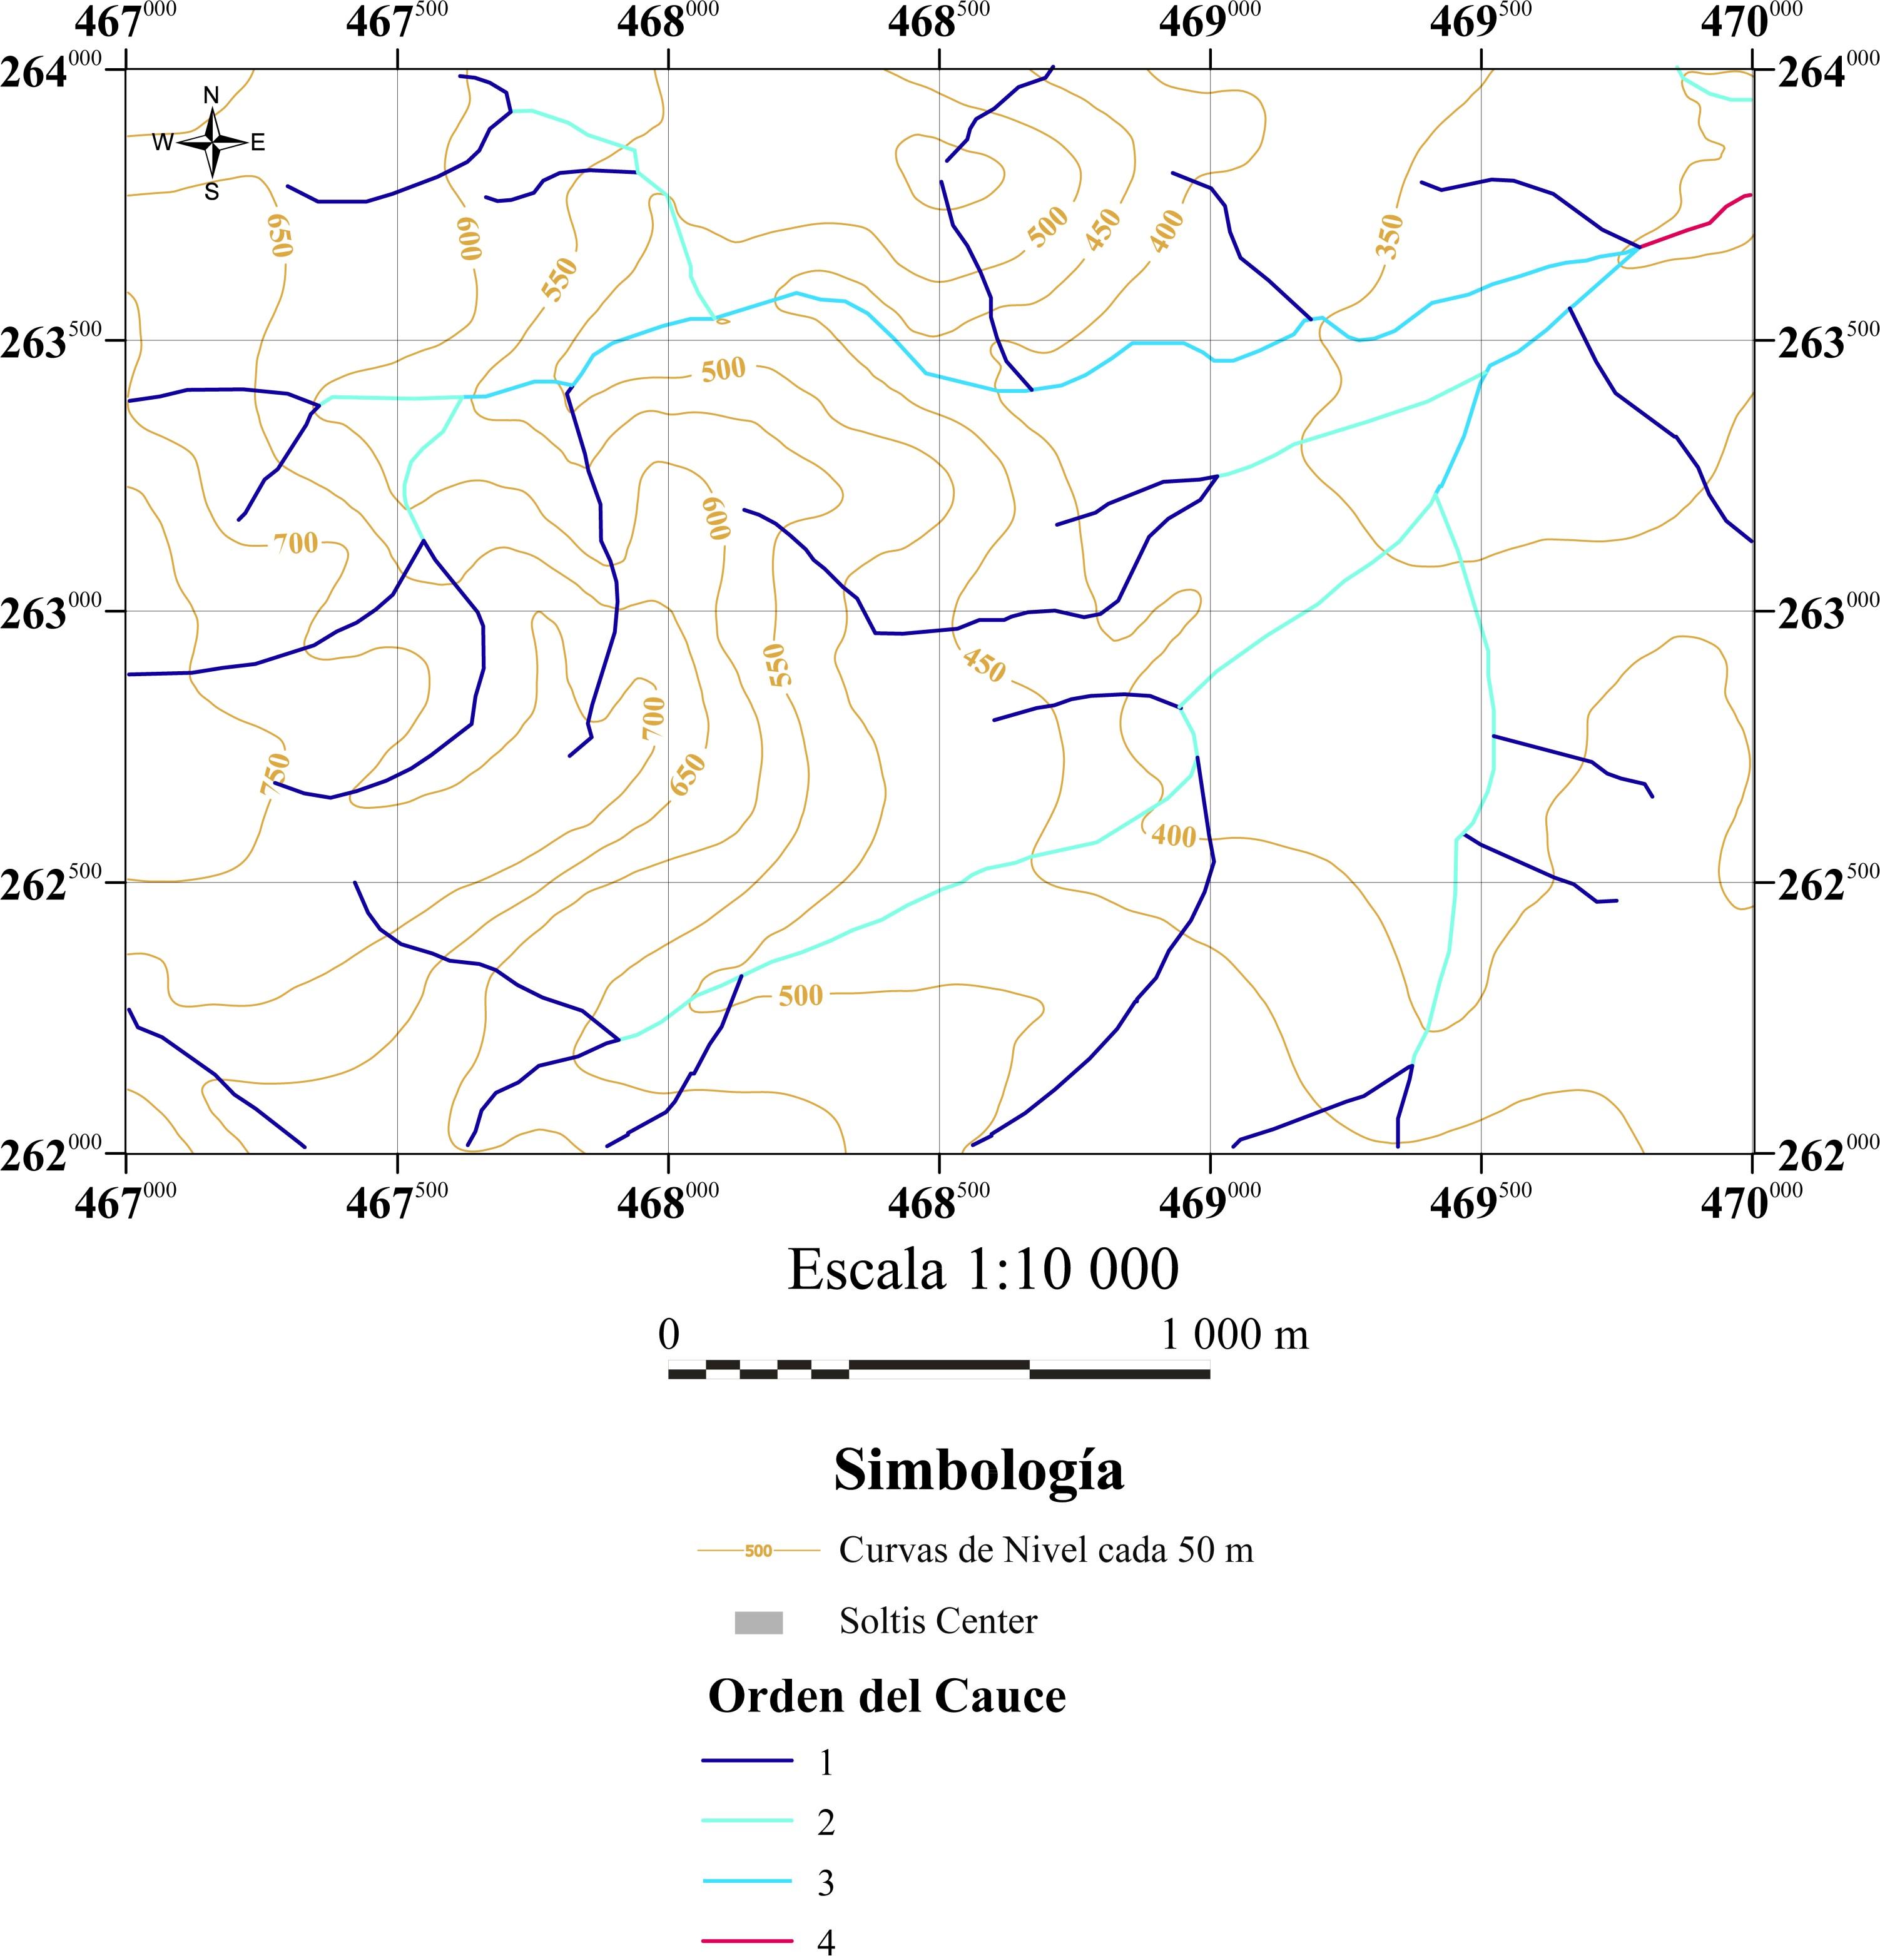

# Figure 11. Channel hierarchy map in the area under study.

### Table 5. Analysis of the hierarchy of channels in the area under study.

|  |  |  |  |  |  |  |
| --- | --- | --- | --- | --- | --- | --- |
| **Order of chann**  **els** |  | **Length of watercourses** | | | **Length ratio (RL)** | **Fork Ratio, (Rb)** |
| **Number of channels** | **Total (m)** | **Average (m)** | **Accumulate d (m)** |
| 1 | 27 | 14239,47 | 527,39 | 14 239 | 1,44 | 3,86 |
| 2 | 7 | 6238,91 | 445,64 | 20 478 | 1,14 | 3,50 |
| 3 | 2 | 2850,86 | 356,36 | 23 329 | 1,02 | 2,00 |
| 4 | 1 | 511,90 | 255,95 | 23 841 |  |  |
| Total | 51 | 23841,14 |  |  |  |  |

When plotting the average length of watercourses against the order, on a semi- logarithmic scale on the Y-axis, an almost perfect alignment of each plotted point is observed, with a slight decrease in the average length as the order of the watercourse increases (see figure 12). This is contrary to what might be expected, since in the quantitative analysis of drainage patterns, it is an axiom that the length of watercourses grows as the hierarchy increases, which is logical considering that watercourses tend to converge in a main one that extends until it flows into a larger body of water, be it the sea, a lake or another river of even greater dimensions.

1000

100

**Average Length**

1234

### Order Number

**Figure 12. Graph of average length vs. hierarchy of channels (semi- logarithmic scale).**

To explain this unusual fact, the most accurate option is that the location of the area under study as well as the surface area it covers (which is too small) influence the analysis. This is due to the fact that the development of the higher order channels is only just beginning, which makes the length within the area insignificant and incomplete when compared to the order 1 channels, which are more numerous and are not biased by the limits proposed for the area under study.

In a graph of the number of channels against the order (see figure 13), an exponential decrease is obtained, in which according to the order of hierarchy, the number of channels increases and the number decreases, which is consistent with the approach for the analysis of drainage patterns.

30



25

20

15

**Number of**

10

5

0

1234

### Order Number

**Figure 13. Chart of number of channels vs. hierarchy of channels.**

Finally, the area under study was divided into sectors of 1/16 of km2 and within each of these quadrants the length of the riverbeds was measured and the number of them counted. With each of these values, contour maps (using the *kriging* interpolation method) and pixel maps were prepared to obtain the drainage frequency [3], drainage density [4] and drainage texture [5], parameters defined below.

F = Total number of channels [3]

d Area

Where:

Fd: Drainage frequency Dd: Drainage density Ta: Drainage texture

D = Length of all channels [4]

Area

d

Ta = Fd × Dd [5]

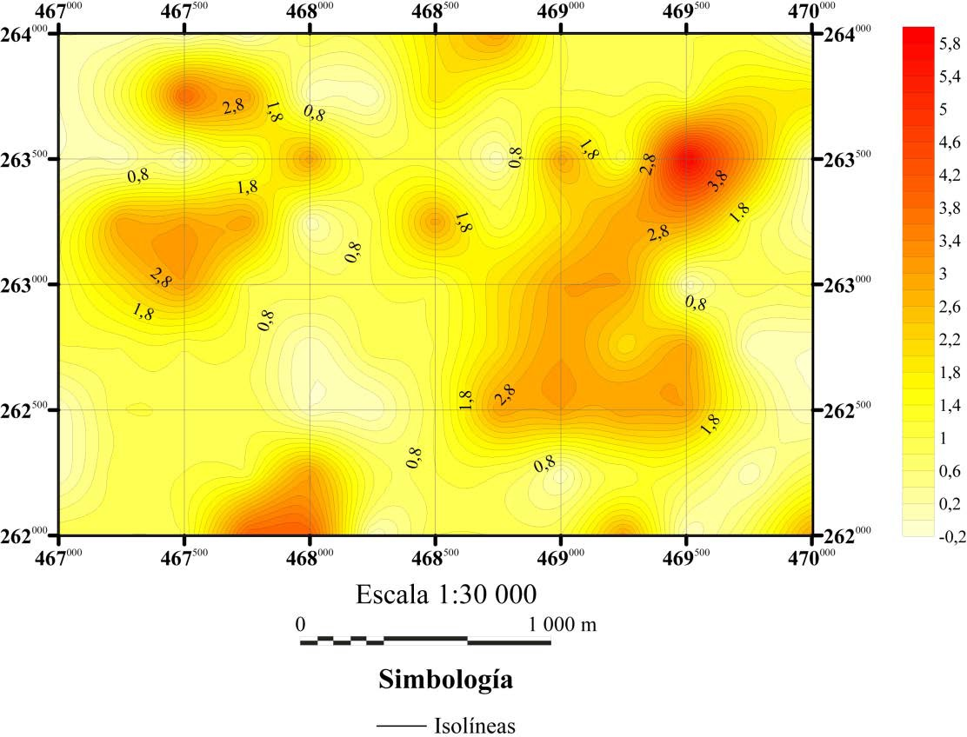Below are the maps for the frequency of drainage (see Figures 14 and 15), in which two important aspects are observed, the first is an increase in the number of tributaries to the Catarata River in the mountainous area and the second is a gradual increase in the number of channels to the east, as one descends from the mountains and the drainage pattern has developed further.

### Figure 14. Contour map of the drainage frequency of the area under study.

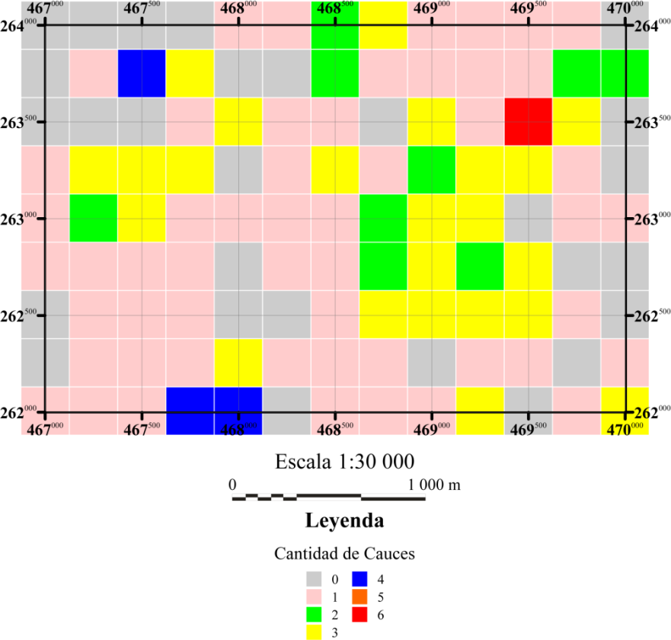

**Figure 15. Pixel map of the drainage frequency of the area under study.**

The drainage density maps (see Figure 16 and 17), show lengths of less than 1 km, because the quadrants are only 1/16 of km2 . In the present case, two peaks are also observed with the same location as in the drainage frequency maps, however, another feature is also distinguished, which consists of the alignment of the contours with a NW direction in the middle of the map, which is related to the change in the terrain topography, where the geomorphological units of Denudational Hills and Foothills are adjacent.

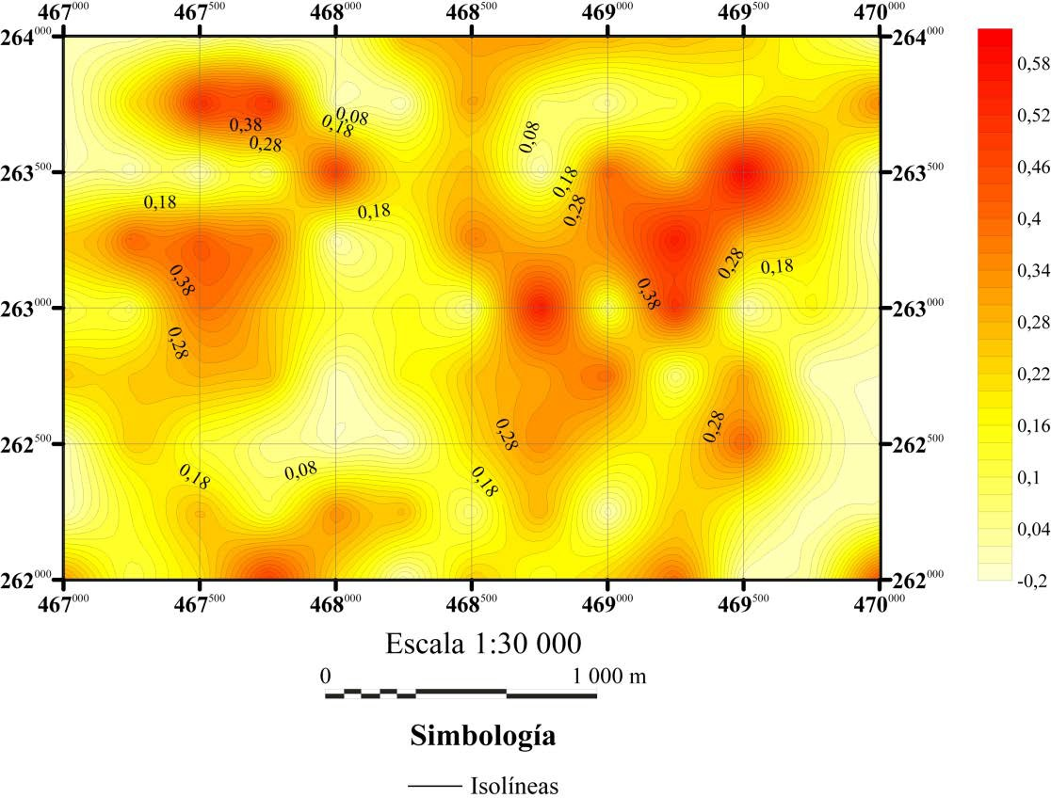

### C:\Users\Javier\Desktop\Javier\Trabajos\Práctica\Informe\Final\Imagenes\Figuras\Densidad Post.tifFigure 16. Drainage density contour map of the area under study.

### Figure 17. Pixel map of the drainage density of the area under study.

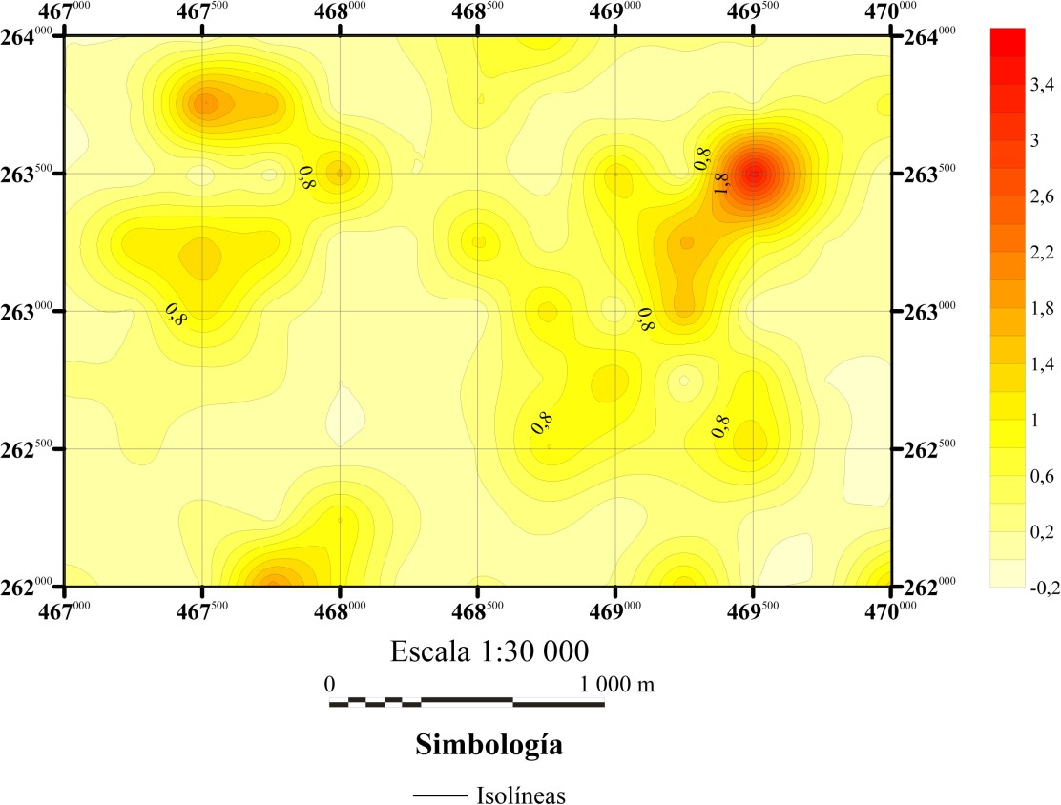In the case of the drainage texture maps (see Figures 18 and 19) it is noted that the largest amount of area is occupied by values in the range of 0 - 0.289, in addition to the same concentrations as mentioned above.

### Figure 18. Contour map of drainage texture of the area under study.

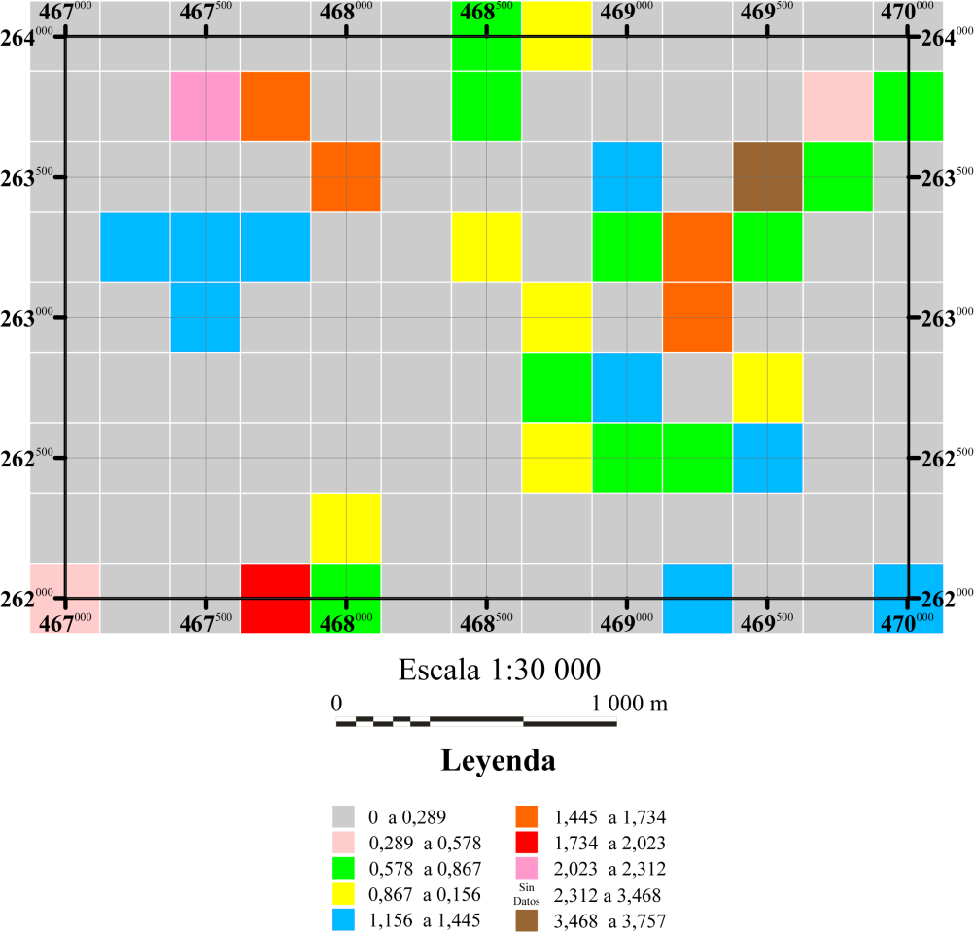

**Figure 19. Pixel map of the drainage texture of the area under study.**

Finally, it can be concluded that the geology of the area has a direct influence on drainage, since the longest riverbeds are found in the most inconsistent and heterogeneous lithologies (Chachaguita and Toba Cangrejera breccia units), while in the Chachagua Andean Basalt Unit the drainage pattern is poorly developed, with low density and frequency.

### Born

The Soltis Center property as well as the surrounding areas have several water springs, some of which are collected and directed for the water supply of both the town of San Isidro and the Soltis Center. These springs are located above the water table, which allows the water to flow out without the need for a pump.

The lithology in which these springs are found is varied, since within the Soltis Center property they are found in the Andean Basaltic Chachagua Unit, while in the westernmost sector of the area under study, outside the property limits they are found outcropping in the Chachaguita Gaps Unit. All of these springs emerge from fissures in the rock, although in some sectors there are escarpments from which water drops emerge, which are usually called "weeping walls".

Within the Sotis Center, the springs can be seen on the Ranario path south of the Tower, at the following coordinates 262 628 N - 468 286 W (534 m above sea level), this has a considerable flow and is used to supply the buildings in the center; to the northwest of the dining room is a spring of water emerging on the right bank of the creek (262 947N - 468 629 W, 408 m.It consists of a hole through which the water emanates, which is approximately 3 m long by 1 m wide and was the spring with the greatest flow of water observed, in comparison with the other springs (see photograph 19).

On the Tomas de Agua trail (as its name suggests), there are several wells as well as the trail that runs parallel to the Chachagua River. The coordinates of these water intakes are as follows: 262 485 N - 468 458 W, 262 416 N - 468 256 W,

262 421N - 468 123W, 262 575N - 468 716 W (see photo 20) and the altitude (in m.a.s.l.)

which are 488, 504, 522, 460 respectively.

Finally, several streams were found that flowed into the Catarata River, which came from springs located a few meters away, mostly on the left bank of the creek. The coordinates where these springs were observed are the following 263 379 N - 468 716 W, at an altitude of 392 m.a.s.l. The flow that came out was

By digging a few centimetres into the ground, the water table can be brought to the surface. By observing the lithology in which the springs to the west of the area under study emerge, it is possible to correlate with that which stores the free aquifer defined by Vargas, which consists of lava blocks intermixed with blocks of tuff, all in an ash matrix (Vargas, 2001), this description is quite similar to that mentioned for the Chachaguita Breccia Unit (see section 3.3.2.). Therefore, it is feasible to consider the free aquifer defined by Vargas for the machinery area of the Peñas Blancas Hydroelectric Project as the same one that

outcrops west of the Soltis Center.

Considering the heights at which the springs and water intakes are located2 , a map of the water table3 (using Surfer version 9.0, *Natural Neighbor* interpolation method) was made, which shows a northeastward flow from the mountains to the lower lands. Figure 20 shows the water table surface for the area under study.

2 It must be clarified that the water intakes are inside cement boxes so it is not possible to observe inside them, however if they have outlet pipes through which the extracted flow was observed. For the purposes of the water table map, the water intakes were taken as springs.

3 The map presented in figure 20 is a simple approximation of how the groundwater flow may occur, therefore the lack of data should be considered as a determining factor when performing the interpolation.

**Glossary**

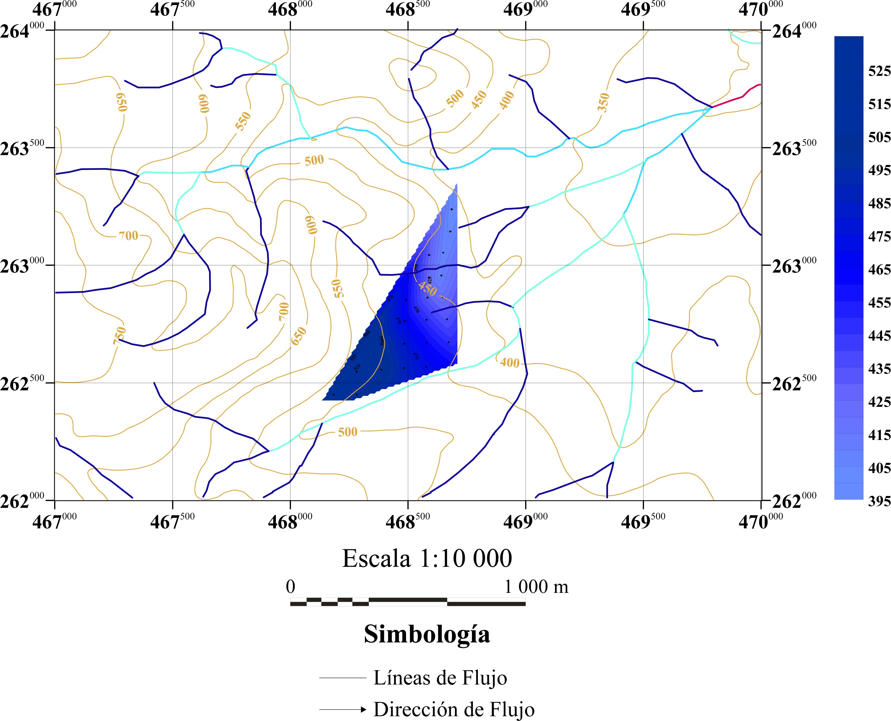

# Figure 20. Proposed water table for the Soltis Center and surrounding areas.

### Rivers and streams

The Soltis Center property is crossed by several rivers and streams that keep the present ecosystems in balance, therefore this section makes a brief review (in a qualitative and subjective way, because no test of gauging, water quality or other was made) of the characteristics observed, such as flow, water turbidity, among others.

Those rivers that can be catalogued as rivers would be the Chachagua and Catarata (informal name given in this work for reference purposes, see figure 1). These rivers have the highest flow observed in the entire area under study, especially the Chachagua River. The water was quite clear, although in those sectors of the river where the water was impounded, it filled with sediment.

Another important point to take into account is the river's dragged edges, as these are indicators of the force of water dragging during floods, a factor to be considered in preventing disasters. In the case of the Chachagua River, blocks of metric size were observed, reaching up to 3 m in diameter; in the case of the Catarata River, blocks of metric size were also observed, although significantly smaller in comparison to those seen in the Chachagua River (maximum 1.5 m in diameter). This indicates that during the rainy season and especially when there is torrential rain, these and in general all the rivers that cross the Soltis Center are extremely dangerous since the flow increases considerably, even giving what is known in CR as "water heads", which are turbulent flows that occur quickly in rivers and streams, dragging all kinds of debris.

Several streams were observed, some of which were dry due to the unusual weather during field visits, as local people commented that there is usually not such a dry and prolonged period. The streams that presented a flow of water were only a few centimeters deep, however the flow was constant. The water was crystal clear and by adding the source (springs) along with the constant flow, one would expect the water quality to be high. The blocks carried by these streams are mostly of sizes

decimeters, however occasionally edges can be found reaching a meter in diameter.

Because these rivers and streams are the basis for the ecosystems and the great biodiversity that inhabits both the Solis Center property and the surrounding forests, it is essential that they be carefully protected, so that both the fauna and flora and the inhabitants of the area will benefit, the former by having sources of food, nutrients and habitat, while the latter by being able to enjoy an incomparable landscape and biodiversity.

**GEOLOGICAL HISTORY**

The origin of the lithology beneath the Soltis Center goes back to the Pleistocene, epoch where an effusive volcanism started and produced the Basaltic Andesite Catarata Unit (Q1-ct). To explain the lava flows at the Soltis Center property, there are two hypotheses, the first one is that they come from a fissure activity or the second one is they come from a volcano. The fissure activity finds more geomorphological evidence, because there are not volcanic structures near the zone that could eject the lava, on the other hand westward can be found several lineaments, which can coincide with the emission source.

The Tuff Cangrejera Unit (Q12-cj) is produced of an explosive volcanism, because the lithology corresponds to high density pyroclastic currents, capable of carrying fragments of rocks, pyroclastic products and ash. The emission source is located to the west, but cannot be defined with major exactitude because the environmental agents seemed to erase it from other places.

Later that the effusive and explosive activity decreased, the unique form of volcanism at the zone was the ascension of termal fluids, which formed the mineralization of pyrite at the Tuff Cangrejera Unit when they cooled. At recent times the zone of San Isidro does not show hydrothermal activity, it seems only to persist at the Poco Sol area.

At some moment ending Pleistocene and initiating Holocene epochs, the erosion of the rock and the important quantity of water at the region, triggered lahares that carry all kind of materials from the mountain zone to the plain zone, flattening the topography and producing the Breccias Chachaguita Unit (Q12-cg). Finally the erosion of the river and creeks that currently continues keeps leveling the topography and forming alluvial deposits.

## GEOLOGICAL HISTORY

The origin of the rocks on which the Soltis Center is located dates back to the beginning of the Pleistocene, when a phase of effusive volcanism began that produced the Andean Basaltic Unit Cataract (Q1-ct). To explain the origin of the lava flows within the Soltis Center property there are two options, coming from the fisural activity or from a volcano. The first one is the most plausible, since there are no remnants of nearby volcanic structures, but to the west of the area under study there are several alignments where some of these may coincide with the emission source.

The Toba Crab Unit (Q12-cj) is a product of explosive volcanism, since the lithology is related to high density pyroclastic currents, capable of carrying blocks of rock fragments, pyroclasts and ash. The source of these flows is located to the west, however it cannot be defined with greater accuracy because the lithology is very localized, which seems to indicate that it was erased in other sectors by environmental agents.

Later, with the decline of the effusive and explosive activity, the only remaining volcanic activity in the area was the ascent of mineral-rich thermal fluids, which, when cooled, produced the pyrite mineralization in the Toba Cangrejera Unit. In recent times the hydrothermal activity seems to have completely ceased in the San Isidro area, while it still persists strongly in the area of Poco Sol.

Sometime at the end of the Pleistocene and beginning of the Holocene, the erosion of the existing rocks and the important presence of water in the region, caused lahars, which dragged all kinds of materials from the mountainous area to the low areas, flattening at first the topography and giving rise to the Chachaguita Breccia Unit (Q12-cg). Finally, the erosive action of the rivers and streams that persists today continues to level the relief and leave alluvial deposits in its wake.

## FINAL CONSIDERATIONS

This abstract summarizes the three final chapters, which are: conclusions, observations and recommendations. Beginning with the conclusions, this paper classified the lithologies found at the study area in five informal units. The Soltis Center is found over the Basaltic Andesite Catarata Unit (Q1-ct), which corresponds with the main unit and it is correlated with Monteverde Formation.

The knick points observed are one of the most outstanding characteristics. On the geological sphere these represents the better outcrops to see the fresh rock. From a geomorphological and structural point of view, these are unique morphologies specifically positioned which allow to see them as a greater structure, that might be a fault or at least a scarp.

On the hydrogeological field, the zone presents a moderate quantity of rivers and creeks that corresponds with the transition from a mountain zone to a plain. On the other hand the aquifer seems to crop out at many topographic levels, according to the high frequency of springs dispersed on the study area.

There are some observations to stand out; the first one is that the knick points and springs are the ideal outcrops in case to collect samples for radiometric dating. The second one is the hydrological potential of the zone, because the water is quite abundant, for that reason it should be carefully care.

The third observation is that the map of figure 20 has many assumptions, for that reason it is advised to see it as a preliminary map that needs more data to assure a true representation of reality. Finally the knick point at the waterfall differs on height from the others, but it is not clear why.

The principal recommendations are: expand the mapping area so the structures and geological features can be seen with more clarity, realize a deepest analysis on the volcanology field that allow to explain the geological history of the zone in a better way, do a detail hydrogeological analysis (pumping test, water quality, infiltration test, etc.) that enable to determine the aquifer and perform a specialized investigation on the knick points to see if they really are from a tectonic control.

## CONCLUSIONS

* The classification of the lithologies present in the area under study led to the definition of five informal units:
  + Basaltic Andean Unit Cataract (Q1-ct) which correlates with the Monteverde Formation and has a Pleistocene age.
  + Toba Crab Unit (Q12-cj) that correlates with Quaternary Epiclastic Rocks and Sediments.
  + Chachaguita Breccia Unit (Q12-cg) correlated with Quaternary Epiclastic Rocks and Sediments.
  + Chachagua Alluvial Deposits Unit (Q2-ch).
  + The San Isidro Quaternary Deposits Unit (Q2-si).
* Tectonic structures such as the inferred SE-NW faults are found in the area, evidenced by the alignment of the *knick points in the* streams and rivers within the Soltis Center.
* Geomorphological analysis reveals that there are five different morphologies: River Canyon, Ravine, Denudational Hills, Slide and Foothill. The area under study is located within the units of Colinas denudacionales and Pie de monte, so there is a clear change in slopes and topography, starting with gentle slopes at low altitude, to reach steep slopes above 500 m.a.s.l. where the Soltis Center property is located.
* The area has a moderate frequency and density of watercourses, which corresponds with the morphology, since this is a transition zone from mountain to plain. On the other hand, the frequency of springs is quite high, since the phreatic level emerges throughout the area under study.
* The geological history of the Soltis Center and its surroundings covers the entire Quaternary, starting with the effusive activity of andesitic lava flows, later on there were pyroclastic flows that were hydrothermally altered and probably at the same time there were lahars that flattened the relief. Finally, fluvial and atmospheric activity have been present at all times, but the main action has been carried out in recent times.

## REMARKS

The outcrops in best condition are located at the *knick points* and the headwaters, so they are ideal sites for dating in the area.

The hydrological potential of the area is very outstanding, so it is essential to take special care of it, since not only do the inhabitants of San Isidro de Peñas Blancas depend on the water extracted from the aquifer, but the whole ecosystem is based on the abundant presence of water.

The map in Figure 20 has many assumptions, indicated in the footnotes, so the flow lines can now change direction. This again makes it clear that the map may not be reflecting reality.

It is not very clear why the *knick point of* the Cataract differs in height from the others.

## RECOMMENDATIONS

Extend the mapping of the area to more sectors, in order to understand and visualize more clearly the geology and geological processes of the studied area.

To carry out a more in-depth analysis in the volcanological field, which will strengthen some aspects already evaluated in the present project and which will help to further elucidate the geological history of the area, especially in the special characteristics indicated in section 3.1.2.

If a more detailed study is carried out, it is recommended to carry out data in the area, so that the different washes in the area can be better differentiated and the different effusive pulses that originated them.

To carry out a detailed hydrogeological analysis (well analysis, pumping and infiltration tests, gauging, water quality, etc.) which determines the aquifer and which establishes in specialized parameters the true hydrogeological potential of the area and which also allows to safely delimit the phreatic surface and the flow lines. Make a detailed statistical analysis of the diaclases found in the upper waterfall, in order to determine the efforts that produced them.

According to the fourth observation, a more in-depth analysis is recommended, both to verify that the origin of all the knick *points is* by tectonic control, as well as to determine which factors influenced the *knick point* found at the Cataract to be more accentuated than the others.

## REFERENCES

AIAZZI, D., FIORLETTA, M., CIVELLI, G., CHIESA, S. & ALVARADO, G., 2004:

Geology of the Cane Leaf - Rev. Amer. Central, 30: 215-223.

ALVARADO, G., 2009: Geology of Fortuna Leaf, Alajuela, Costa Rica - Rev.

Amer. Central, 41: 117-122.

ALVARADO, G. & GANS, P., 2012: Geochronological synthesis of magmatism, metamorphism and metallogeny in Costa Rica, Central America - Rev. Geol. Central, 46: 7-122.

ANONYMOUS, 1984: Fortuna Topographic Sheet - Scale 1: 50000, IGN, San José GUILLOT, P., CHIESA, S. & ALVARADO, G., 1994: Chronostratigraphy of Upper

Miocene-Quaternary volcanism in northern Costa Rica.- Rev. Geol. Amér. Central, 17: 45-53.

LORD, M., GERMANOSKI, D. & ALLMENDINGER, N., 2009: Fluvial geomorphology: Monitoring stream systems in response to a changing environment.- En: YOUNG,

R. & NORBY, L. (eds.): Geological Monitoring.- The Geological Society of America: 69-103.

MADRIGAL, C., 2004: Conceptual hydrogeological model of the section of aquifers located under the site of the powerhouse of the Peñas Blancas Hydroelectric Project, Costa Rica - 71 p. University of Costa Rica, San José [Thesis M.Sc.]

MADRIGAL, C., BONILLA, J., ÁVILA, M., ALVARADO, G.E. & BARQUERO, R.,

1995: Geological study of alternatives 1 and 5 of the Peñas Blancas Hydroelectric Project - 24 pages + plans. Instituto Costarricense de Electricidad [Internal information].

MORA, S., 1977: Geological study of Cerro Chopo - Rev. Central, 1(5-6): 189-199.

PORRAS, H., CASCANTE, M., GRANADOS, R. & ALVARADO, G., 2012: Volcano

stratigraphy and tectonics of the Western Central Valley and the foothills of the Avocado Mountains along Route 27, Costa Rica - Rev. Amer. Central, 47: 63-93.

VARGAS, J., 2001: Geology, hydroheochemistry and conceptual model of reservoir for the pre-feasibility of the Poco Sol geothermal field, San Ramón - San Carlos, Costa Rica - 151 p. University of Costa Rica, San José [Thesis M.Sc.]

HAVLÍČEK, V., VOREL, T., KYCL, P., HUAPAYA, S., MIXA, P., GRYGAR, R., ŽÁČEK, P., HAVLÍČEK, S., HRADECKÝ, P., METELKA, V., 'EVCÍK, J. &

PÉCSKAY, Z., 2012: Geology and Stratigraphy of Sheet 3246-II Miramar, Costa Rica - Rev. Amér. Central, 47: 7-57.

## GLOSSARY

**Aquifer:** aquifer Aphanitic

**Bloom:** outcrop **Bloom:**

crop out **Alignment:**

lineament

Hydrothermal alt**eration Height:** height

Alluvial**:** alluvial Basaltic andesite Angled **Augita:** Augite **Barranco:** gully, ravine

**Base:** baseBiodiversity**:** biodiversity

**Block:** boulder

**Forest:** forest Gap:

gap

**Water head:** flash flood

**Street:** street **Way:**

road **Song:** cobble

River canyon: river canyon Powerhouse**:** powerhouse River channel

**Lava** flow**: lava** flow Denudational **hills** Stratigraphic column

**Coluvials:** colluvial Dining room**:** dining room

**Confined [**aquifer**]:** confined [aquifer] **Consolidation:** consolidation **Coordinates:** coordinates

Crystal: crystal Crystal**:** see Clean **Cumulite:** cumulite

**Level curves:** level contours **Due to:** because of **Deleznable:** brittle

**Tank:** deposit **Right:** right **Slide:** slump **Diaclase:** joint

**Discordant:** disconformity Disseminated: disseminated **Distribution:** distribution Dormitories: dormitories **Ecosystem:** ecosystem **Age:** age

**Entry:** entrance Epiclastic: epiclastic Rainy season **Erosion:** erosion

Scarp

**Flower** structure Fault

Phenocrystal**:** phenocrystal

**Figure:** figure **Flow:** flow **Training:** training

**Photography:** photography Genesis: genesis Geomorphology: geomorphology **Big:** big **Grey:** gray

Pebble: pebble **Hydrogeology:** hydrogeology Idiomorphic: idiomorphic **Tilt:** dip

Kinematic **indicator Left:** left **Hierarchy:**

hierarchy Hillside

**Lahar:** lahar

**Laja:** layered lava, national term to refer a piece of lava that it is layered

Thin **sheet:** thin section Ballast: ballast [road]: clear [**water]:** lithology

**Type of location:** type locality

**Location:** locality

**Macla:** twin **Map:**

map

Margins [**river]:** margins [river]

**Matrix:** matrix

Morphometric method Microcrystalline Morphology**:** morphology

**Morpho-neotectonics:** morpho- neotectonic

**Born:** spring **Niche:** notch Water table **Name:** name **Olivino:** Olivine **Landscape:**

landscape

Conjugate pair [faults**]:** conjugate pair [faults]

Parallel

**Paredes lloronas:** weeping walls, national term to refer a wall that constantly drips water

Drainage **pattern** Slope **Small:** little **Profile:** Cross section

**Permeability:** permeability **Petrographic:** petrographic Foothills: foothills **Piritization:** pyritization **Plagioclase:** Plagioclase Porphyritic: porphyritic **Well:** well

Presenta**:** presents

Primary [road**]:** primary [road]

**Depth:** depth

Stereographic **projection**

**Peñas Blancas** Hydroelectric Project**:** Peñas Blancas hydroelectric project Public: public

**Dot:** waypoint **Gorge:** creek **Pink:** pink

Secondary [road**]:** secondary [road]

**Sediment:** sediment **Selection:** sorting **Path:** trail **Symbology:** symbology

Subdendritic**:** subdendritic

**Size:** size

**Tectonic:** tectonic

**Ranario:** frog pond **Rounded:** rounded Dam: dam Streams **River:** river **Rocks:** rocks

**No name:** no name

Tertiary [**road]:** tertiary [road] Earth**:** earth **Toba:**

tuff **Location:** location **Unit:** unit **Trail:** pathway Field trip: field trip

Volcanism: Xenomorphic volcanism: xenomorphic

## ANNEXES PETROGRAPHIC ANALYSIS

Code: CL-1

Origin: Soltis Center, cut on the Catarata trail, 100 m before the Catarata Described by: Javier Oviedo González

### Macroscopic description:

Light grey colour rock, little weathered, with aphanitic porphyritic texture, fine to medium grain. It presents phenocrystals of plagioclase with a minimum size of 2.12x0.95 mm and a maximum of 5.03x2.14 mm, in approximately 30%; pyroxene crystals with a minimum size of 0.86 mm in diameter and a maximum of 2.56x1.13 mm, with a percentage of approximately 5%. The matrix is fine grained grey with a proportion of 65%. The sample has a weathering patina of 9.94 mm thickness.

### Microscopic description:

Hypocrystalline hypidiomorphic porphyritic texture with hyalopylitic matrix.

### Mineralogical composition:

***Pheno-crystals* 55%.**

**Plagioclase:** hypidiomorphic to ideomorphic crystals with maximum size 2.35x1.2 mm and minimum 0.094x0.047 mm, presenting polysynthetic macles. They are altered to clay and sericite. They represent approximately 37% of the total sample.

**Augite:** hypidiomorphic crystals of maximum size 1.2x0.55 mm and minimum size 0.05x0.03 mm Some crystals present alteration to hematite. They represent 13% of the total sample.

**Hyperstene:** presents a hypidiomorphic shape, with maximum sizes of 0.33x0.1 mm and minimum 0.12x0.05 mm. It is found in 2%.

**Opaque:** xenomorphic pyrite crystals, with maximum diameters of 0.1 mm and minimum of

0.01 mm, in approximately 3% of the total section.

**Accessories:** quartz crystals with an average diameter of 0.14 mm are available

***Matrix* 45%**

Hyalophile texture composed of microlites of plagioclase, augite, opaque and glass.

**Name:** Andesite with augite.

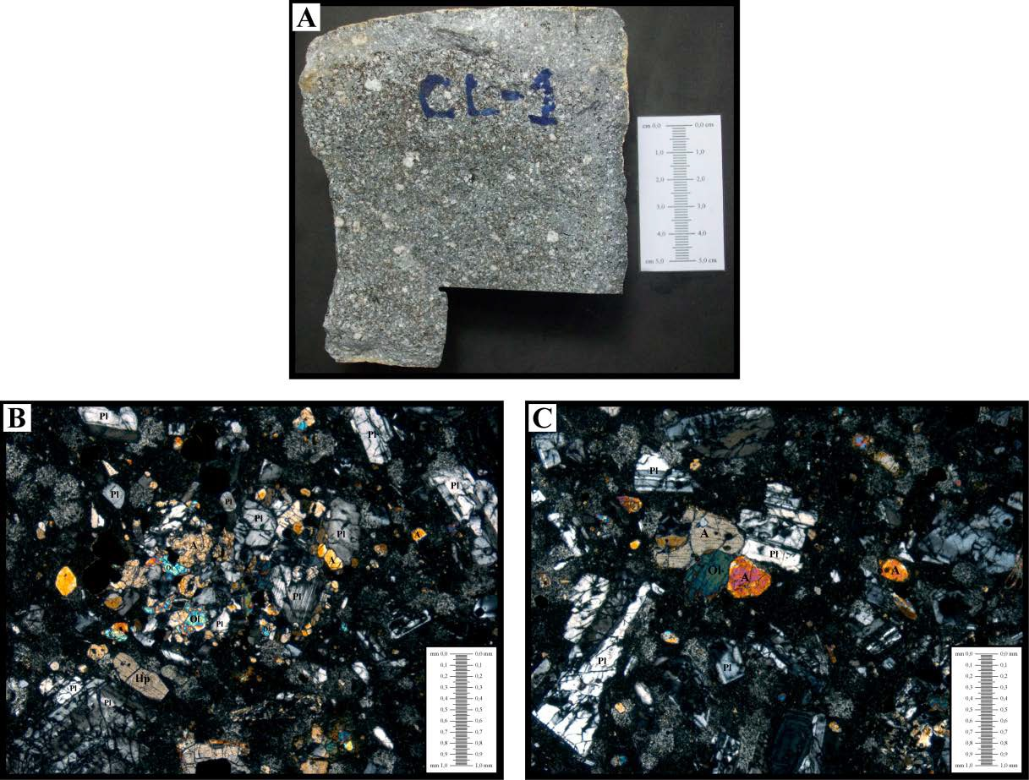

**Sample CL-1. A - Hand sample. B - Microphotography, crossed nicols, 4X magnification.**

**C - Microphotography, crossed nicols, 4X magnification.**

Code: RC-1

Origin: Soltis Center, block deposited by the Chachagua River on the banks of the bridge Described by: Javier Oviedo González

### Macroscopic description:

Dark grey rock, not very weathered, with aphanitic porphyritic texture, fine grain. It presents phenocrystals of plagioclase with a minimum size of 1.97x0.8 mm and maximum of 3.9x2.32 mm, in approximately 20%; pyroxene crystals with an average size of 1.63 mm in diameter. The matrix is fine grained grey with a proportion of 76%. The sample has a weathering patina of 1.9 mm thickness.

### Microscopic description:

Serial glomeroporphyritic hypocrystalline texture with fine to medium hyalophile matrix.

### Mineralogical composition:

#### Phenocrystals 36%

**Plagioclase:** hypidiomorphic crystals with a maximum size of 2.82x2.82 mm and a minimum size of 0.094x0.024 mm, presenting polysynthetic macles and zoning. They are altered to clays. They represent approximately 28% of the total sample.

**Augita:** cristales xenomórficos de tamaño máximo 1,88x0,94 mm y mínimo 0,024x0,03 mm. Representa un 6% del total de la muestra.

**Opacos:** cristales xenomórficos, con tamaños máximo de 0,47x0,235 mm y diámetro mínimo de 0,024 mm, en aproximadamente un 2% del total de la sección.

***Matriz* 64%**

Textura hialopilítica compuesta por microlitos de plagioclasa y poco vidrio.

**Name:** Andesite with augite.

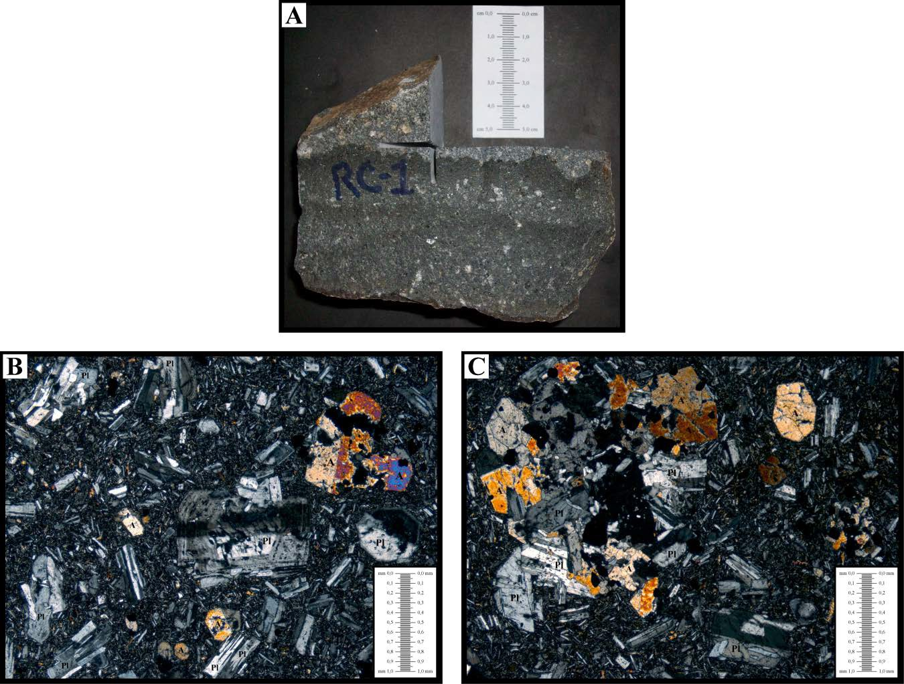

**Muestra RC-1. A – Muestra de mano. B – Microfotografía, nicoles cruzados, aumento 4X. C – Microfotografía, nicoles cruzados, aumento 4X.**

Código: SC-1

Procedencia: Soltis Center, Catarata Describió: Javier Oviedo González

### Descripción macroscópica:

Roca color gris oscuro, poco meteorizada, con textura afanítica porfirítica, de grano grueso. Presenta fenocristales de plagioclasa tabulares sin ninguna orientación, con un tamaño mínimo de 2,53x0,74 mm y máximo de 7,35x1,83 mm, en aproximadamente un 12%. La matriz es de color gris oscuro de grano fino con pequeños cristales de plagioclasa menores al milímetro, con una proporción de 88%.

### Microscopic description:

Textura hipocristalina hipidiomórfica porfirítica con matriz de grano fino.

### Mineralogical composition:

#### Fenocristales 16%

**Plagioclasa:** cristales hipidiomórficos a ideomórficos con tamaño máximo 8,7x1,9 mm y mínimo 0,58x0,44 mm, presentan maclas polisintéticas. Se encuentran alteradas a arcilla. Representa aproximadamente un 10% del total de la muestra.

**Olivino:** cristales hipidiomórficos de tamaño máximo 2,35x1,9 mm y mínimo 0,52x,0,36 mm. Algunos de los cristales se encuentran alterados a iddingita, especialmente en los bordes. Representa un 5% del total de la muestra.

**Opacos:** cristales xenomórficos, con diámetros máximo 0,71 mm y mínimo de 0,03 mm, en aproximadamente un 1% del total de la sección.

***Matriz* 84%**

Textura pilotaxítica intersertal, con microlitos de plagioclasa, augita y poco vidrio.

**Nombre:** Andesita con olivino.

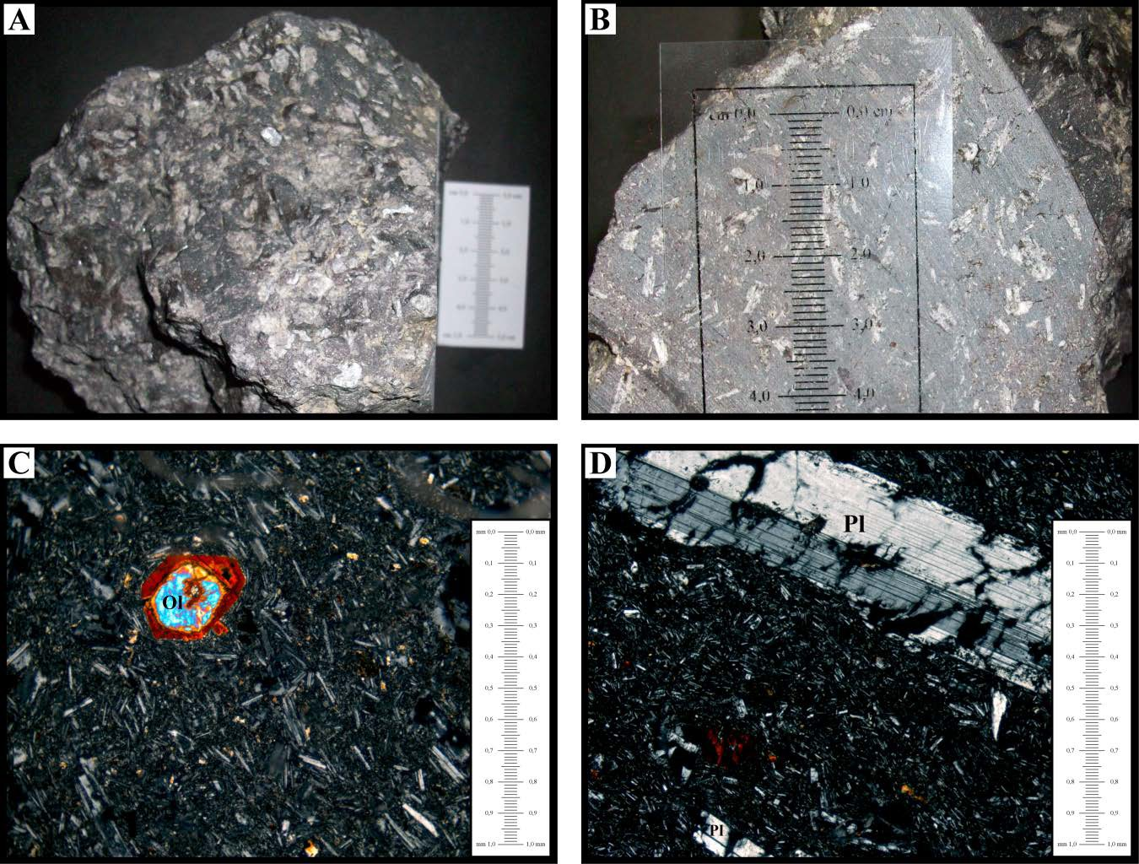

**Muestra SC-1. A – Muestra de mano. B – Detalle del corte en la muestra de mano.**

**C – Microfotografía, nicoles cruzados, aumento 10X. D – Microfotografía, plagioclasa, nicoles cruzados, aumento 10X.**

Código: SC-2 Procedencia: Soltis Center

Describió: Javier Oviedo González

### Macroscopic description:

Roca color gris claro, meteorizada, con textura afanítica porfirítica, de grano fino a medio. Presenta fenocristales de piroxeno con un tamaño mínimo de 0,79 mm y máximo de 2,4 mm de diámetro, con una abundancia de 10% aproximadamente. La matriz es de color gris claro de grano fino con una proporción de 90%.

### Microscopic description:

Textura hipocristalina glomeroporfirítica seriada con matriz de grano fino y fenocristales de plagioclasa, augita, opacos e hipersteno.

### Mineralogical composition:

#### Fenocristales 38%

**Plagioclasa:** cristales hipidiomórficos a ideomórficos con tamaño máximo 3,3x1,4 mm y mínimo 0,05x0,024 mm, presentan maclas polisintéticas y zonación. Se encuentran alteradas a arcillas. Representa aproximadamente un 30% del total de la muestra.

**Augita:** cristales hipidiomórficos de tamaño máximo 2,35x1,18 mm y mínimo 0,071x0,024 mm. Representa un 5% del total de la muestra.

**Hipersteno:** presenta forma hipidiomórfica, con tamaños máximos de 0,52x0,12 mm y mínimo 0,047x0,071 mm. Se encuentra en un 2%.

**Opacos:** cristales xenomórficos de pirita, con tamaño máximo de 0,47x0,35 mm y mínimo de 0,047x0,024 mm, en aproximadamente un 3% del total de la sección.

***Matriz* 62%**

Textura hialopilítica compuesta microlitos de plagioclasa (0,071x0,024 mm) y gran cantidad vidrio.

**Name:** Andesite with augite.

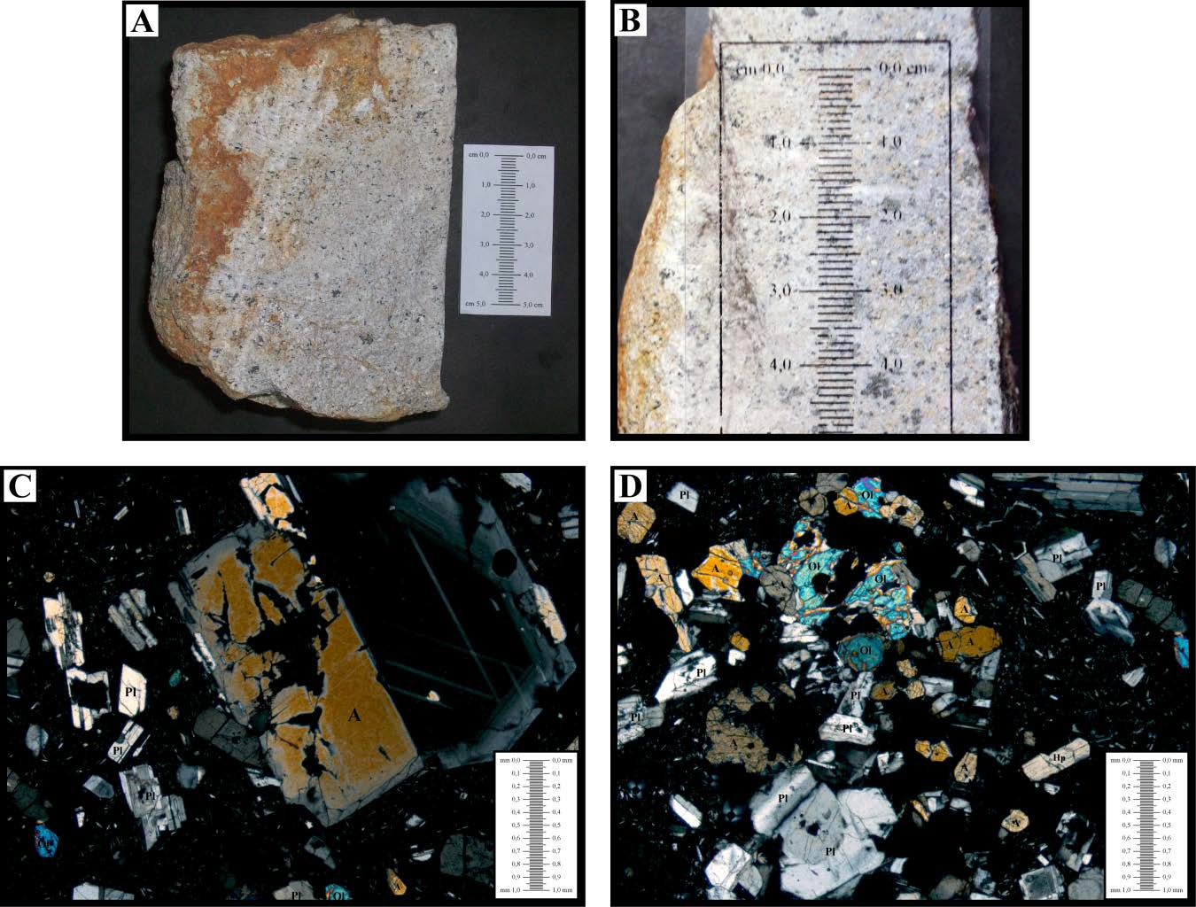

**Muestra SC-2. A – Muestra de mano. B – Detalle del corte en la muestra de mano.**

**C – Microfotografía, nicoles cruzados, aumento 4X. D – Microfotografía, cumulito, nicoles cruzados, aumento 4X.**

Código: SC-3

Procedencia: Soltis Center, corte en el sendero Torre Describió: Javier Oviedo González

### Descripción Microscópica:

Textura hipocristalina porfirítica, con grado de meteorización muy avanzado. Se observan cristales de plagioclasa y principalmente fantasmas de plagioclasa y augita, con alteración en los bordes a hematita. Por comparación a las otras secciones petrográficas observadas y a la muestra de mano se puede deducir que la muestra corresponde a una andesita muy meteorizada.

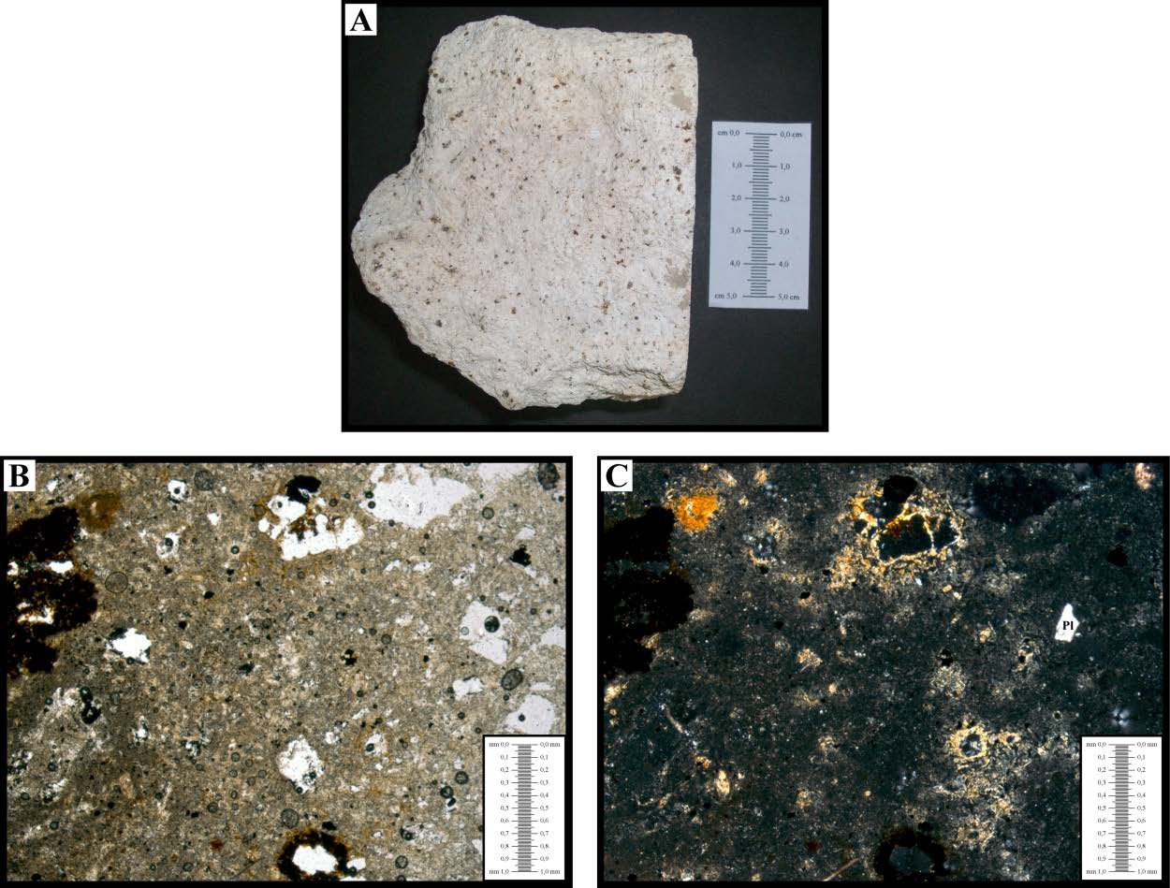Nombre: Andesita altamente meteorizada

**Muestra SC-3. A – Muestra de mano. B – Microfotografía, nicoles paralelos, aumento 4X. C – Microfotografía, nicoles cruzados, aumento 4X.**

Código: CAN-1 Procedencia: La Cangrejerra

Describió: Javier Oviedo González

### Macroscopic description:

Roca color gris claro, sumamente alterada, con clastos de tamaño mínimo de 2,54x1,96 mm y máximo de 2,57x9,21mm, en aproximadamente un 35%. La matriz es arcillosa de color gris, en la que se observan cristales (indeterminables por la alteración), en tonos de gris más oscuro que el resto de la matriz y cristales de pirita, con tamaños menores al milímetro.

### Microscopic description:

Textura hipocristalina porfirítica alterada hidrotermalmente, con matriz de grano fino y fenocristales de cuarzo, olivino y pirita.

### Mineralogical composition:

#### Fenocristales 35%

**Cuarzo Secundario:** cristales xenomórficos con tamaño máximo 0,083x0,065 mm y mínimo 0,05x0,01 mm. Representa aproximadamente un 3% del total de la muestra.

**Olivino:** cristales xenomórficos de tamaño máximo 0,072x0,53 mm y mínimo 0,042x0,026 mm. Representa un 6% del total de la muestra.

**Líticos:** presentan formas redondeadas, elípticas hasta esféricas, con tamaños máximos de 9,81x7,51 mm y mínimo 2,13x1,60 mm. Se encuentra en un 17%.

**Pirita:** cristales xenomórficos, con tamaño máximo de 0,55x0,35 mm y mínimo de 0,07x0,04 mm, en aproximadamente un 9% del total de la sección.

***Matriz* 65%**

Textura vitrofírica.

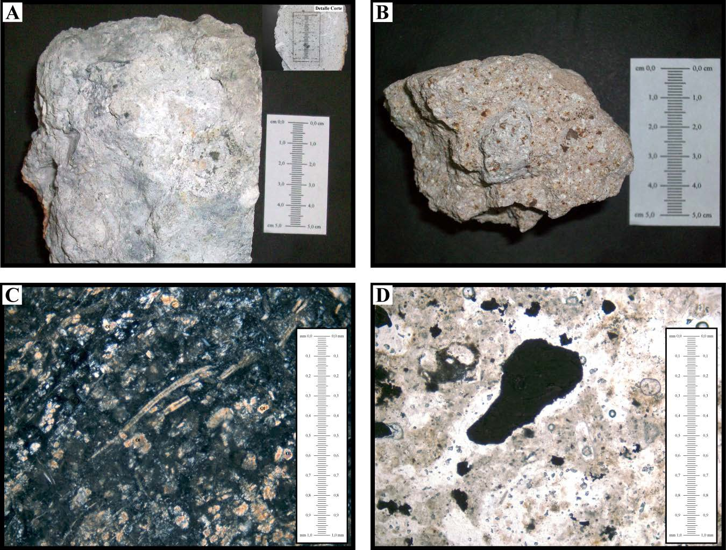**Nombre:** Toba lítica.

**Muestra Toba Lítica-1. A – Muestra de mano CAN-1, recuadro: detalle del corte. B – Muestra de mano recolectada en el punto 24. C – Microfotografía CAN-1, nicoles cruzados, aumento 10X. D – Microfotografía CAN-1, nicoles paralelos, aumento 10X.**

## OTRAS MUESTRAS

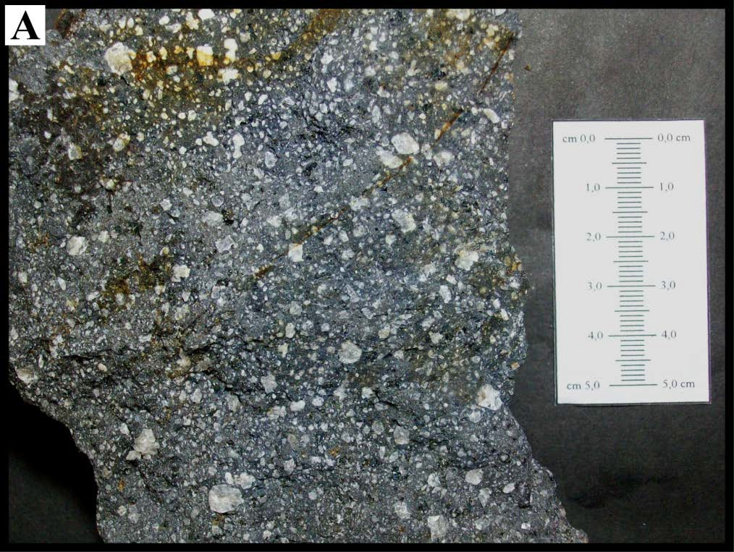

**Muestra Andesita Río Chachagua. A – Muestra de mano de un bloque arrastrado por el río Chachagua.**

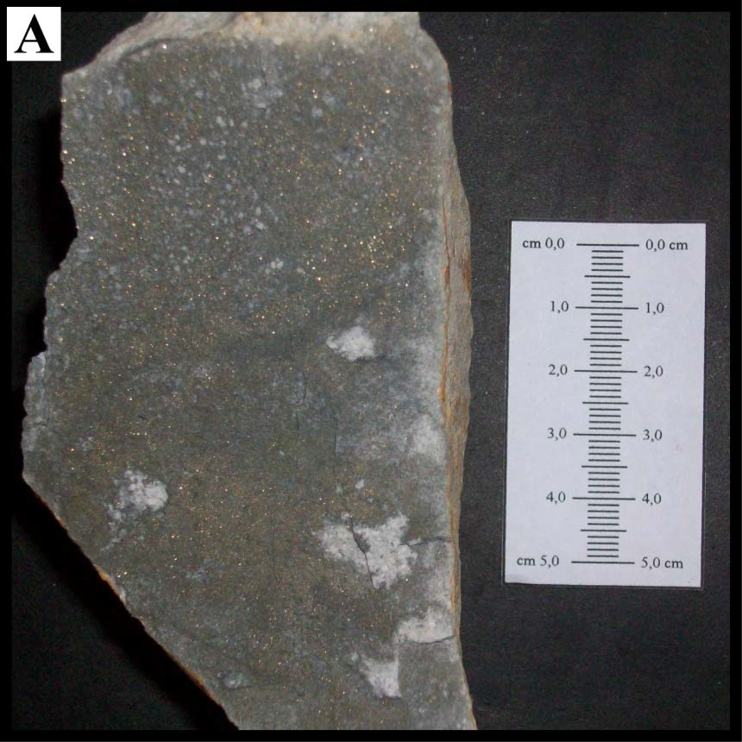

**Muestra Toba Cangrejera. A – Muestra de mano con alteración hidrotermal y piritizació****n.**

## FOTOGRAFÍAS

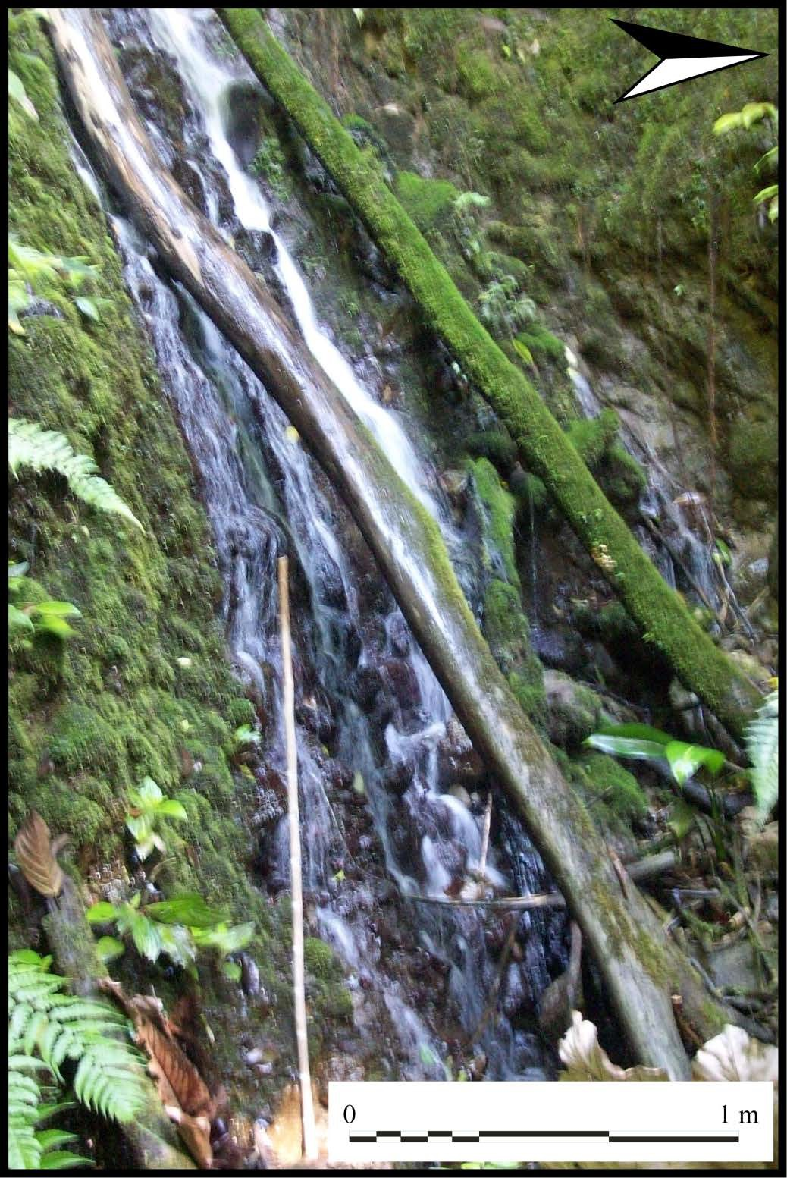

**Fotografía 1. *Knick point* quebrada Sin Nombre 1**

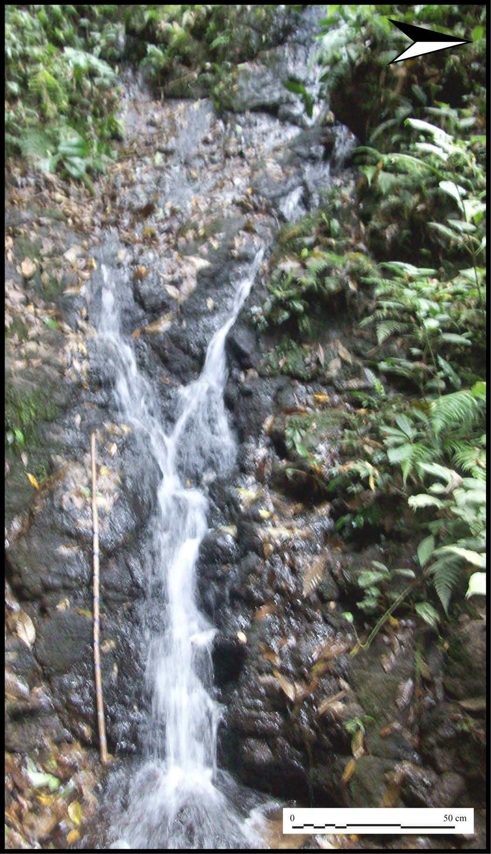

**Fotografía 2. *Knick point* inferior quebrada Sin Nombre 2.**

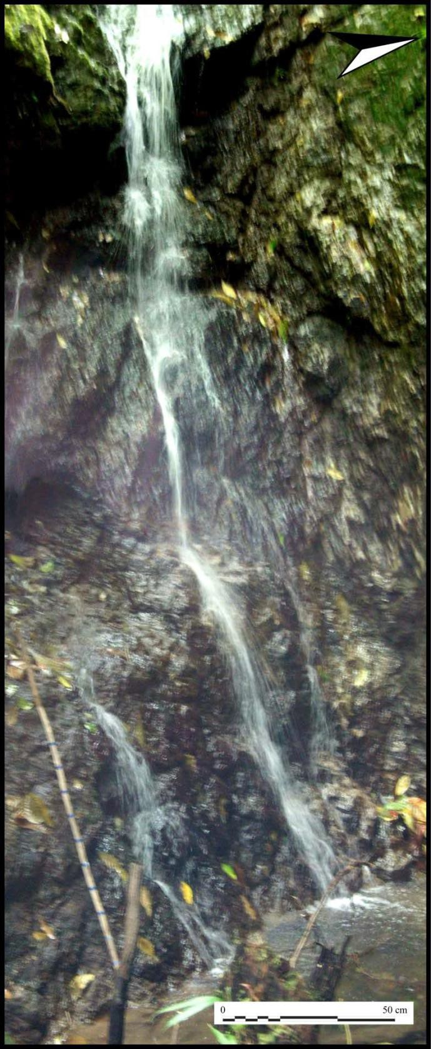

**Fotografía 3. *Knick point* superior quebrada Sin Nombre 2.**

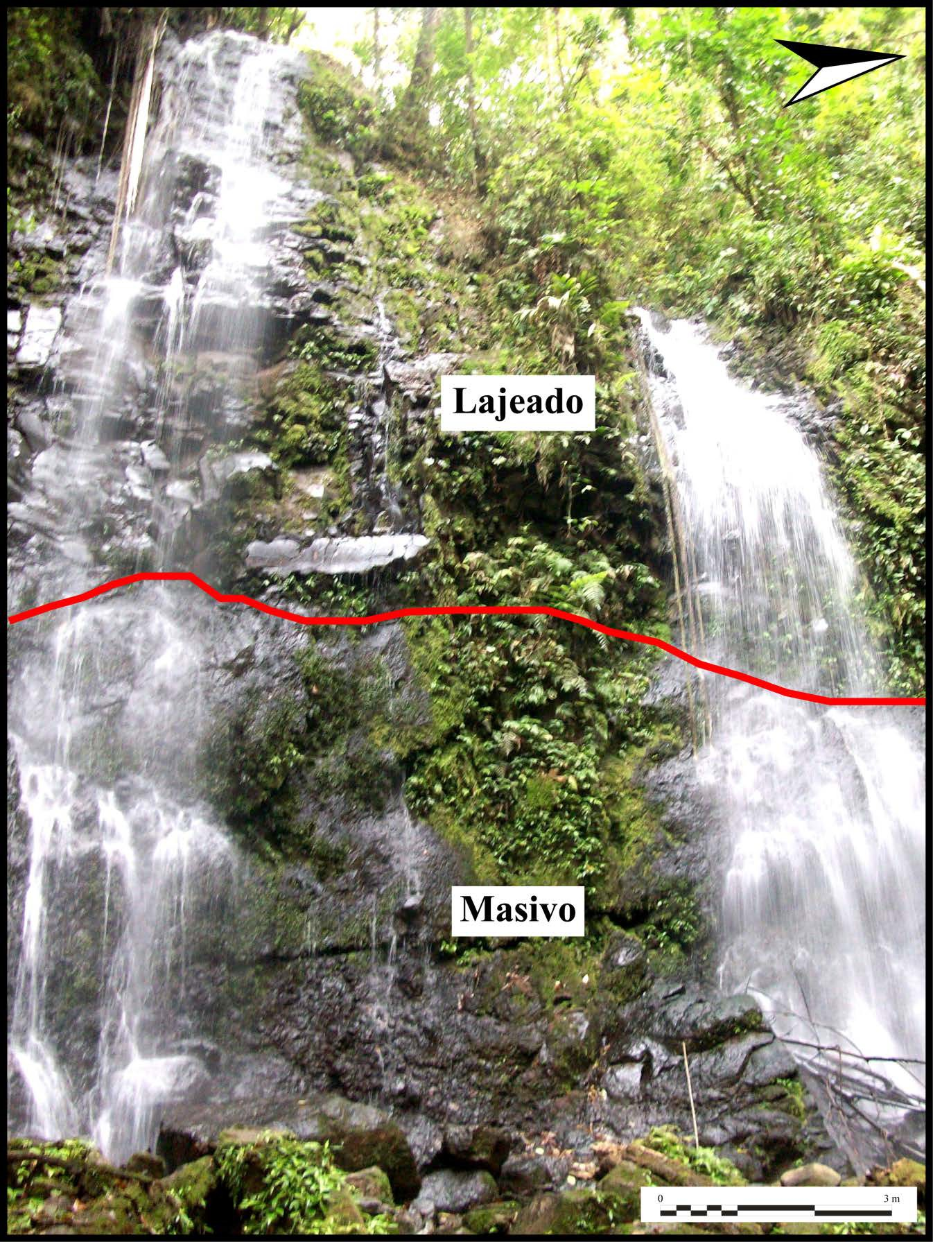

**Fotografía 4. *Knick point* inferior en el río Catarata.**

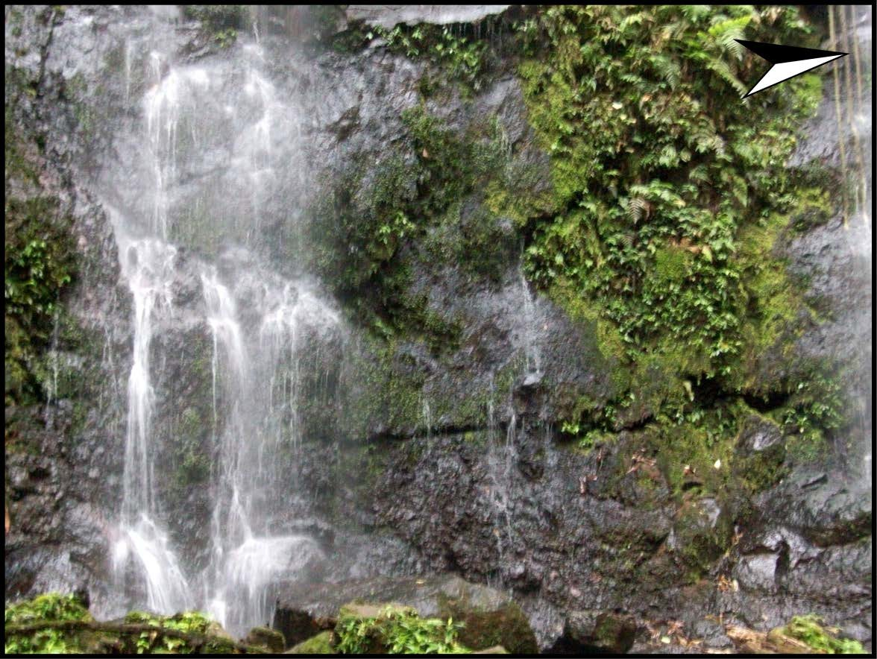

### C:\Users\Javier\Desktop\Javier\Trabajos\Práctica\Informe\Final\Imagenes\Fotografias\Catarata Parte Superior.tifFotografía 5. Detalle de la parte inferior de la Catarata.

**Fotografía 6. Detalle de la parte superior de la Catarata**

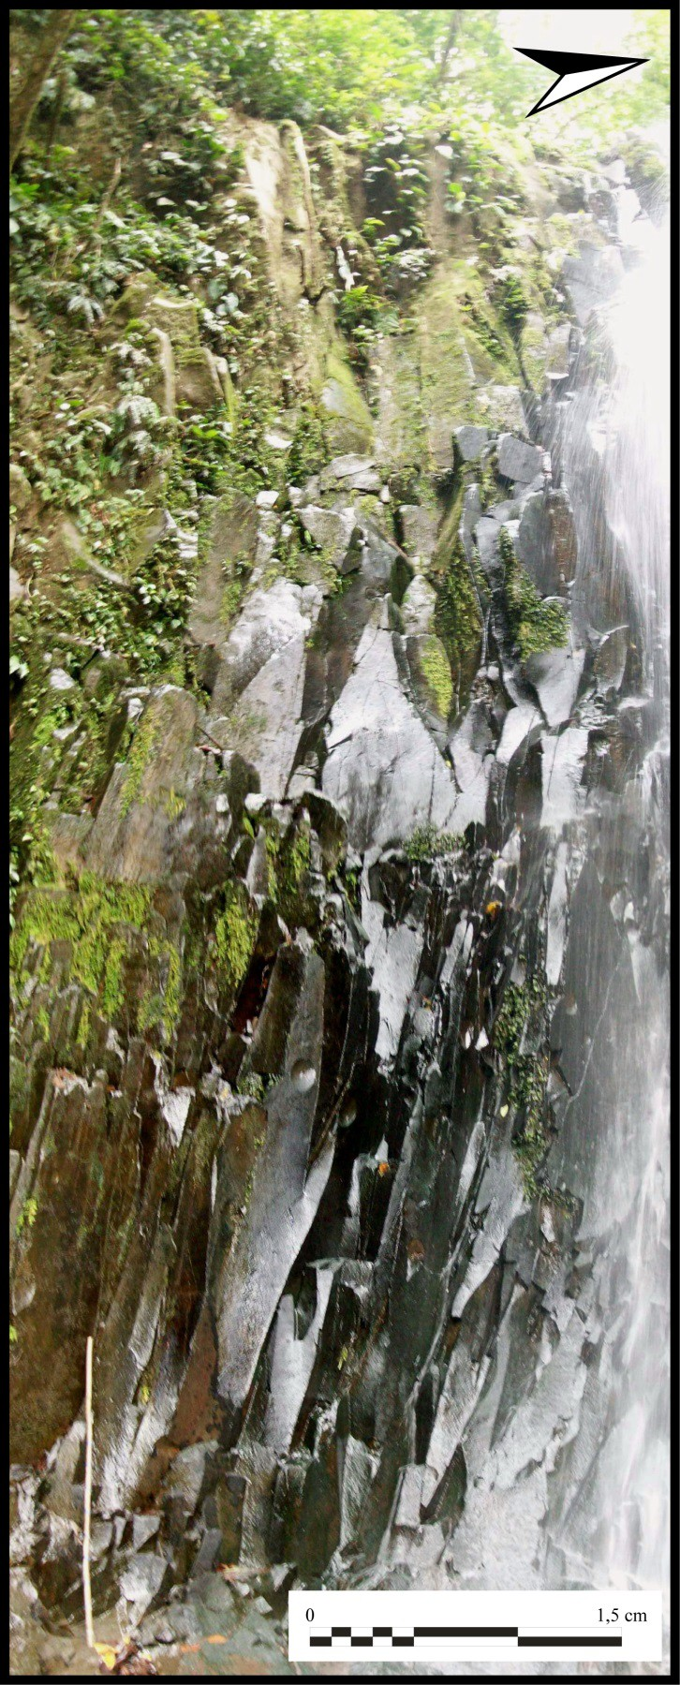

**Fotografía 7. *Knick point* superior del río Catarata.**

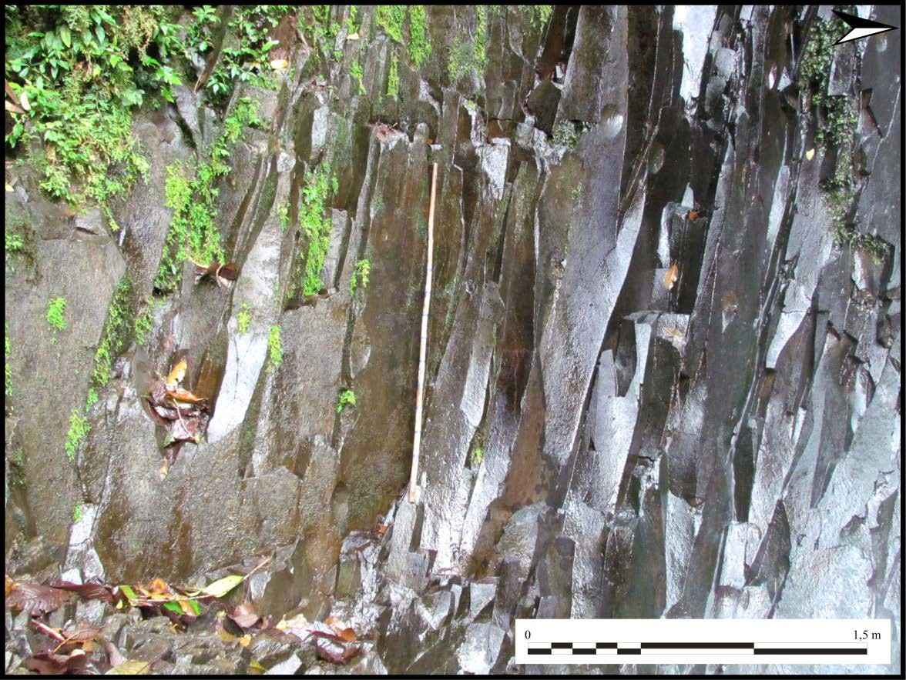

#### Fotografía 8. Detalle de las columnas en el knick point superior del río Catarata.

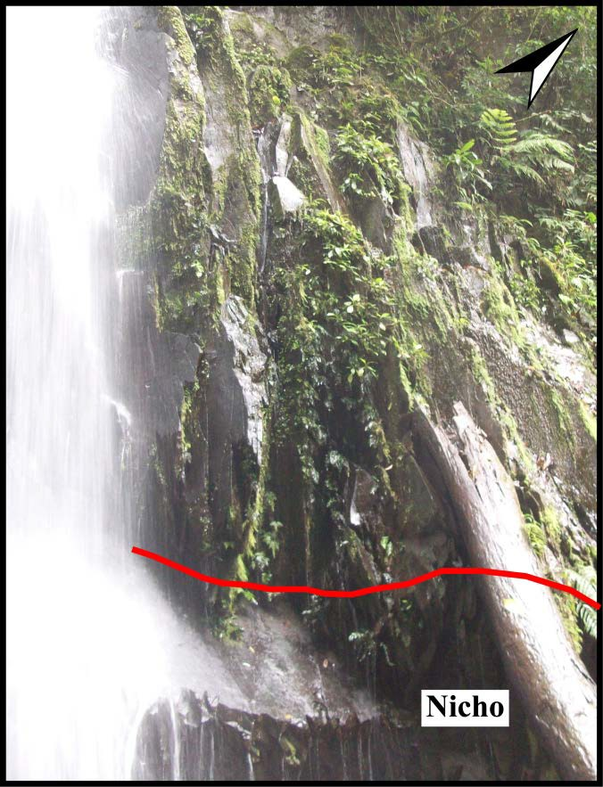

**Fotografía 9. Detalle de la margen izquierda río Catarata en el *knick point* superior.**

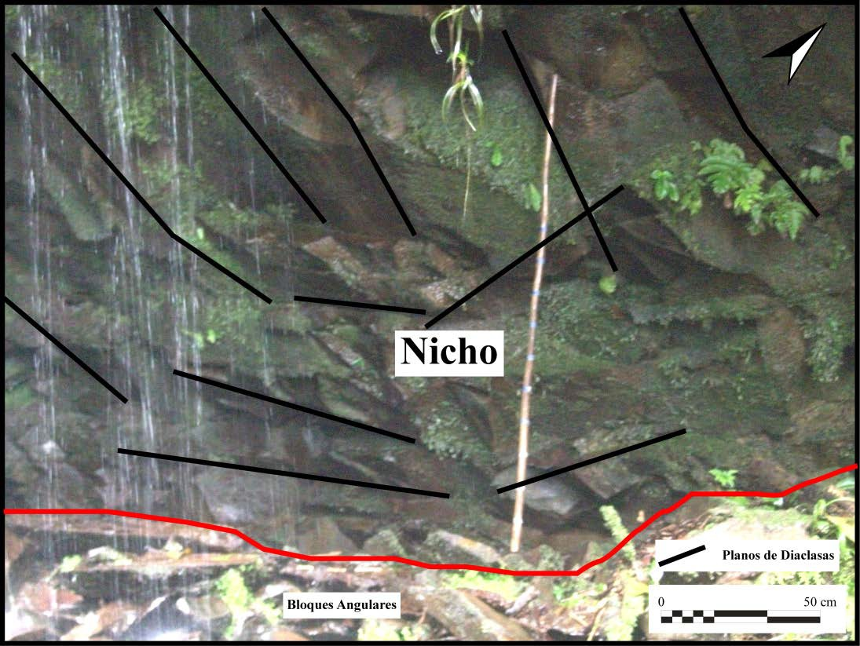

**Fotografía 10. Detalle del nicho y las diaclasas en la margen izquierda río Catarata en el *knick point* superior.**

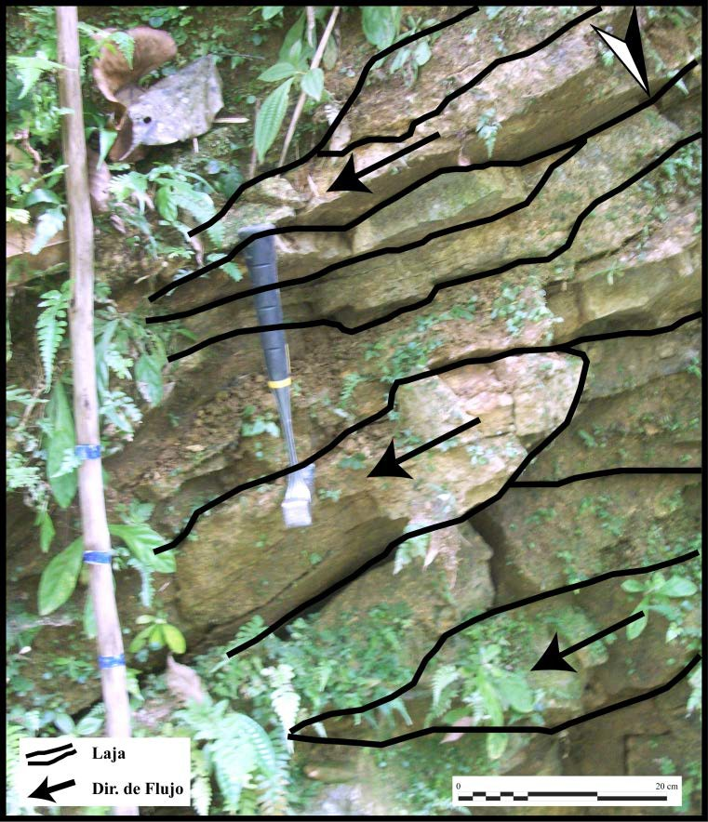

**Fotografía 11. Corte en el sendero antes de llegar a la Catarata, detalle de las lajas.**

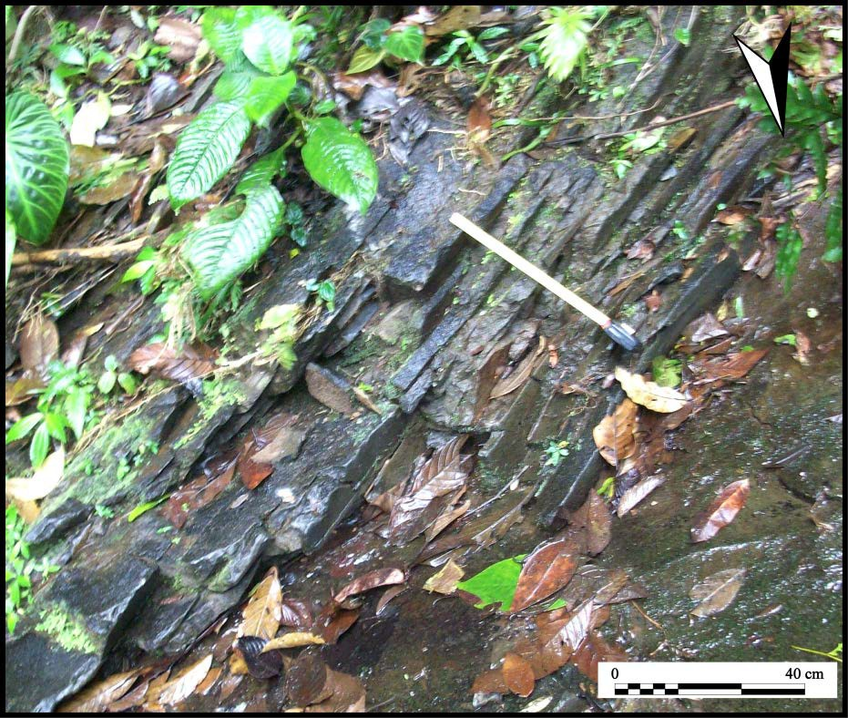

**Fotografía 12. Lajas formadas en el *knick point* superior del río Catarata (margen derecha).**

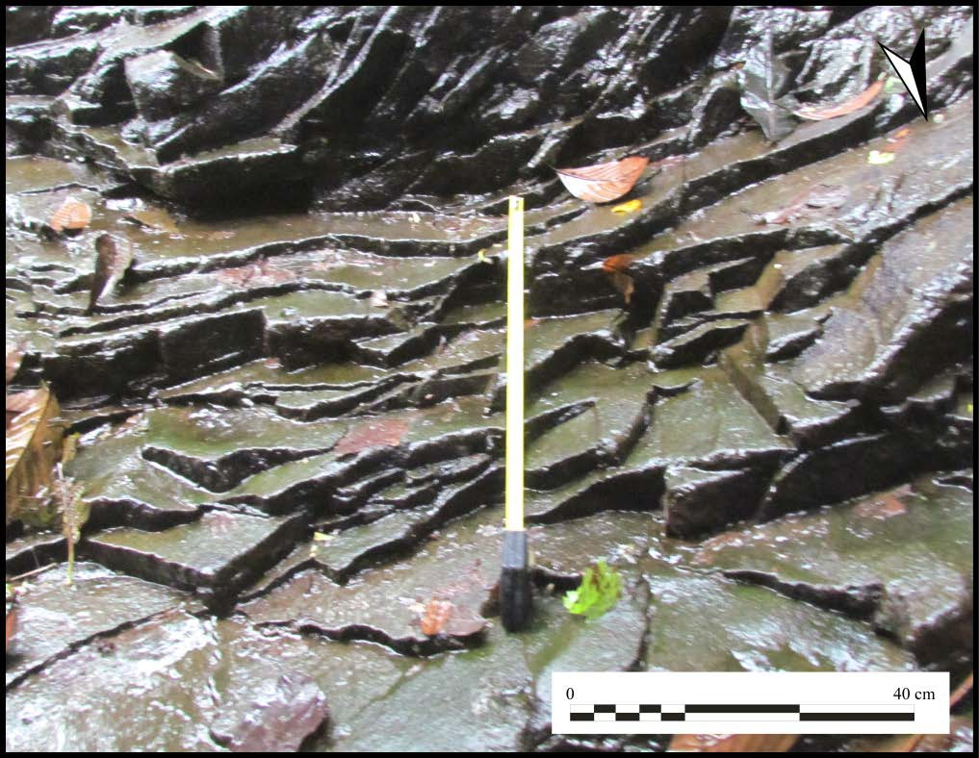

**Fotografía 13. Lajas formadas en la base del *knick point* superior del río Catarata (margen derecha).**

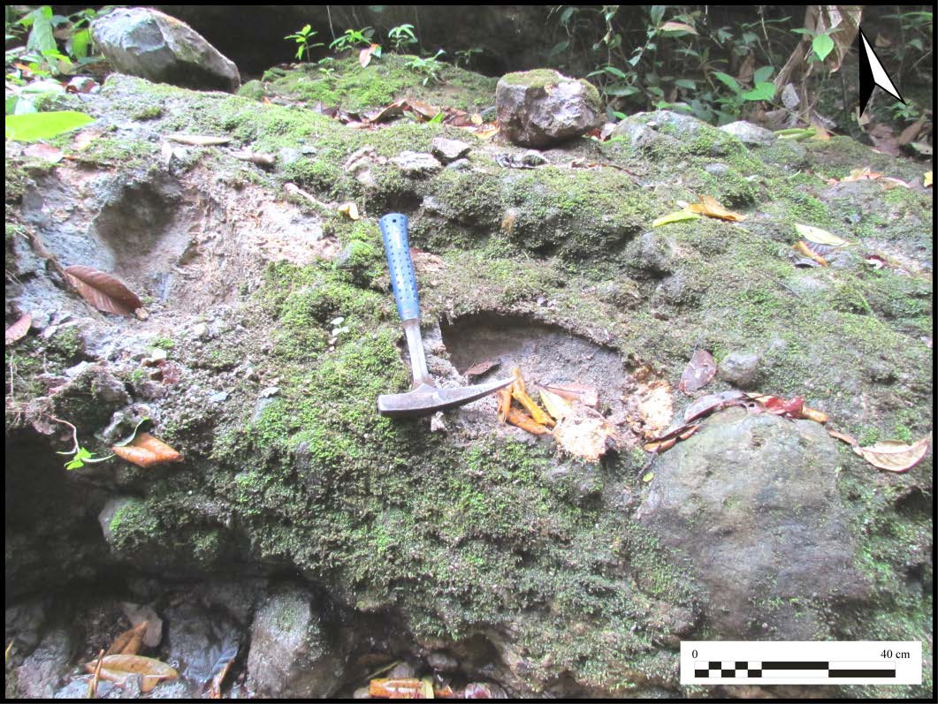

**Fotografía 14. Brecha formada por el lahares en un afluente al río Catarata (margen izquierda), punto 25.**

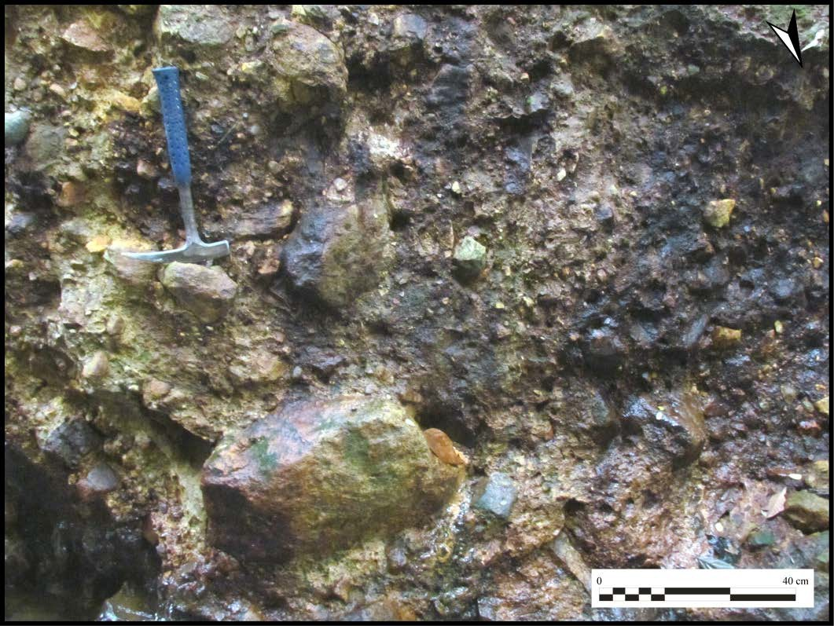

**Fotografía 15. Brecha formada por el lahares en un afluente al río Catarata (margen derecha), punto 27.**

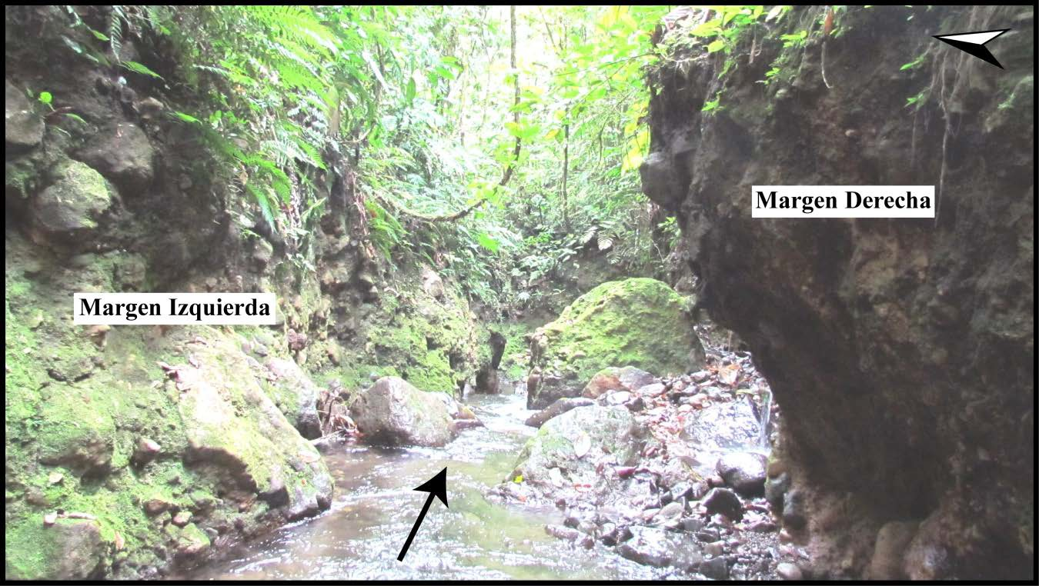

**Fotografía 16. Afluente al río Catarata (punto 27), obsérvese la brecha en ambas márgenes del río.**

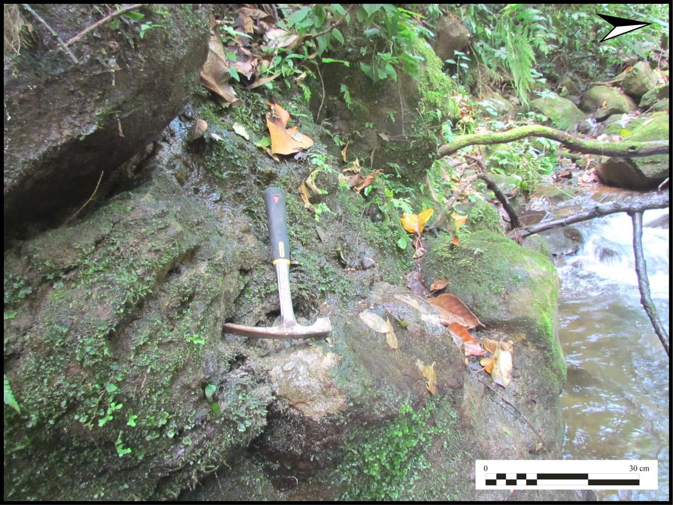

**Fotografía 17. Río Chachagua, margen derecha.**

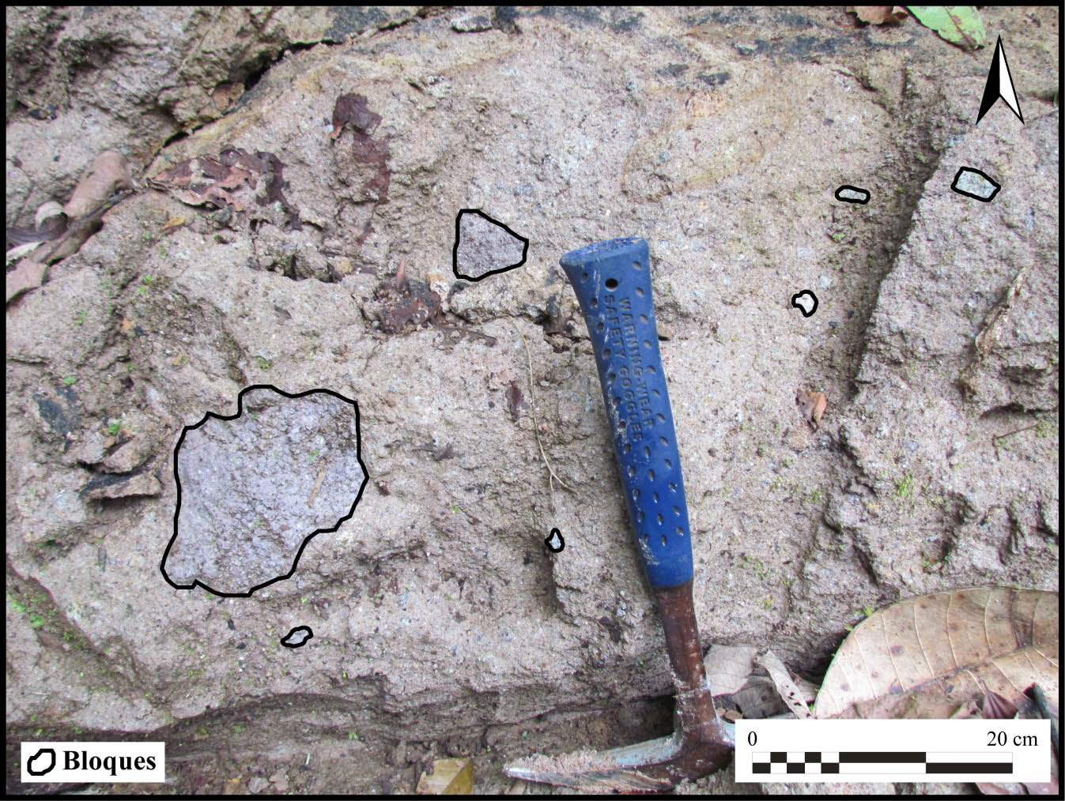

**Fotografía 18. Toba, punto 25.**

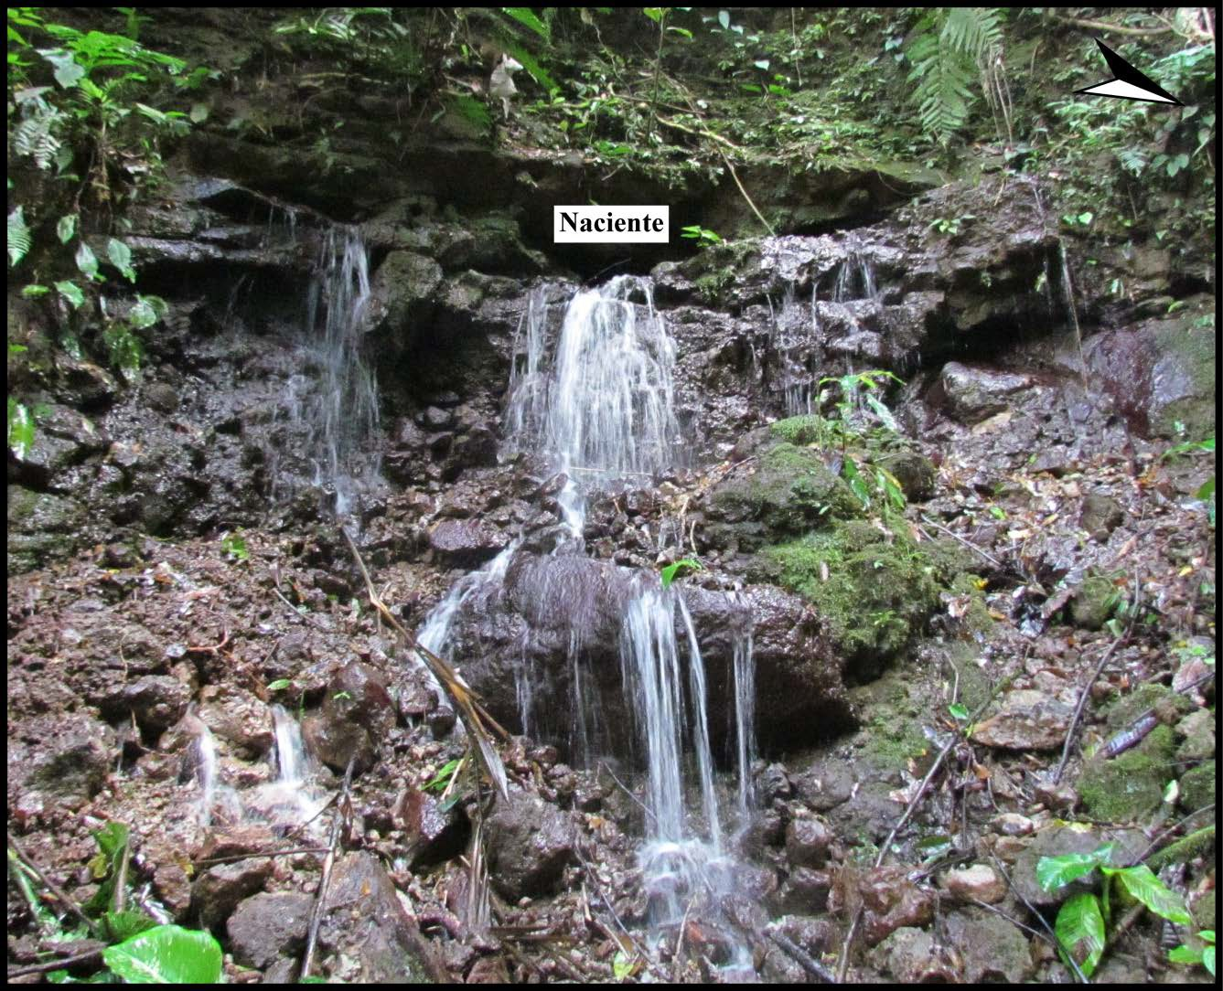

**Fotografía 19. Naciente dentro de la propiedad del Soltis Center, punto 28.**

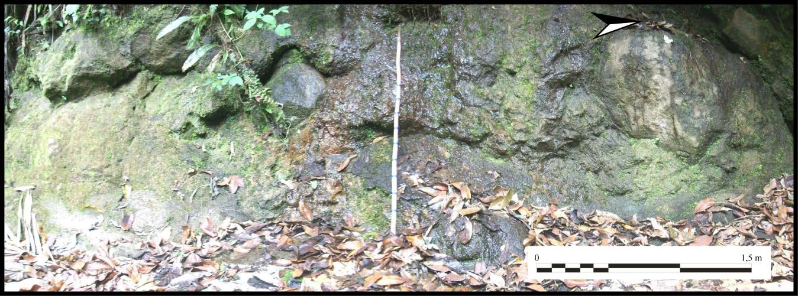

**Fotografía 20. Naciente al final del sendero Tomas de Agua, punto 21.**

### MODELOS 3D

**Imágenes (Screenshots)**

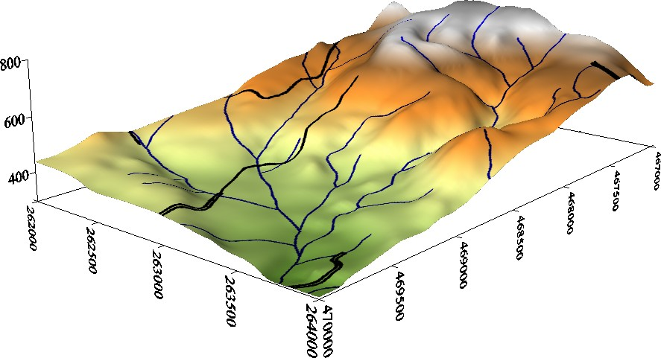

**Modelo 1. Modelo de elevación digital realizado con el programa Surfer, versión 9.0.**

**Referirse a la simbología de la figura 1.**

**Interactivos (interactive), realizados con el programa ArcScene, versión 10.0.**

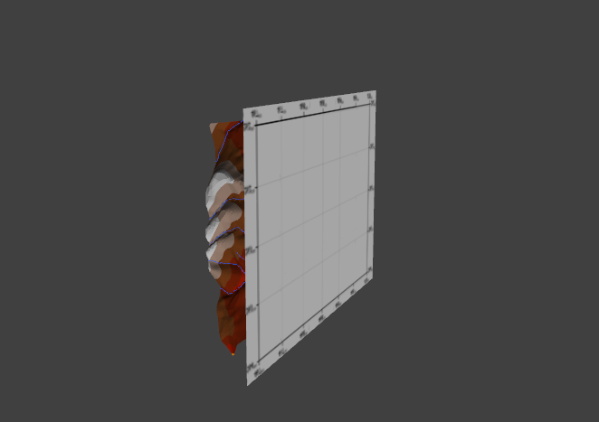

**Modelo 2. Modelo de elevación digital, escala de colores cada 50 m.**

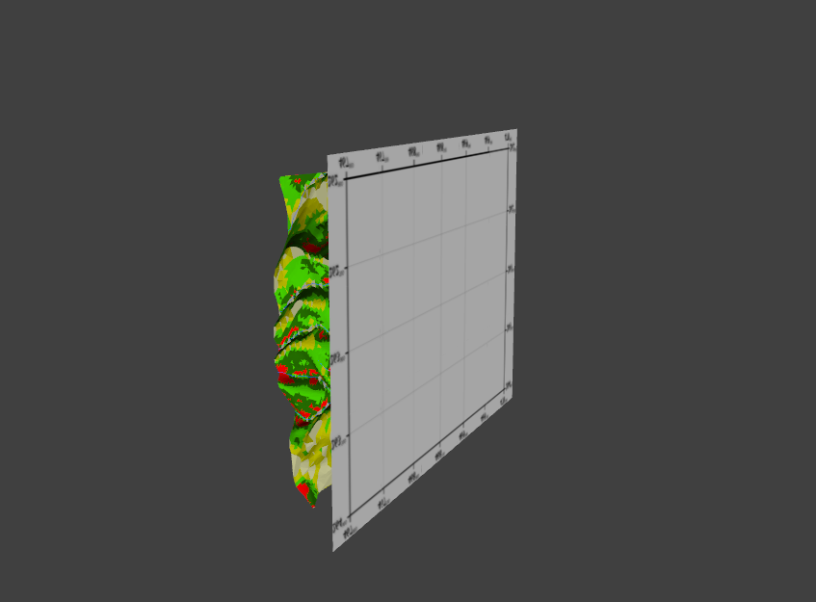

**Modelo 3. Modelo de pendientes, referirse a la leyenda de la figura 9.**

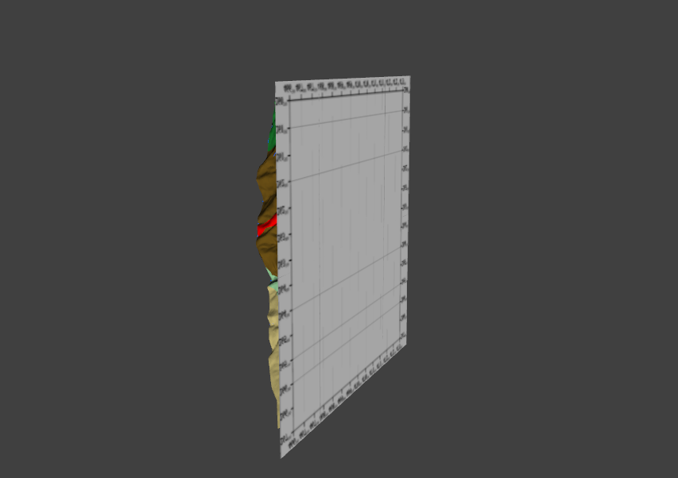

**Modelo 4. Modelo de las unidades geomorfológicas, referirse a la leyenda de la figura 8.**

**METODOLOGÍA Y CONCEPTOS**

**Método de Horton-Strahler**

<http://www.fgmorph.com/fg_4_8.php>

#### Método de Jacob

[http://www.hwe.org.ps/Education/Birzeit/GroundwaterEngineering/Chapter%203%20-](http://www.hwe.org.ps/Education/Birzeit/GroundwaterEngineering/Chapter%203%20-%20Groundwater%20Flow%20to%20Wells.pdf)

[%20Groundwater%20Flow%20to%20Wells.pdf](http://www.hwe.org.ps/Education/Birzeit/GroundwaterEngineering/Chapter%203%20-%20Groundwater%20Flow%20to%20Wells.pdf)

[http://content.alterra.wur.nl/Internet/webdocs/ilri-publicaties/publicaties/Pub57/pub57-](http://content.alterra.wur.nl/Internet/webdocs/ilri-publicaties/publicaties/Pub57/pub57-h4.pdf) [h4.pdf](http://content.alterra.wur.nl/Internet/webdocs/ilri-publicaties/publicaties/Pub57/pub57-h4.pdf)

<http://core.ecu.edu/geology/spruill/spruill/Groundwater%20Notes%20No.%207.pdf>

#### Cumulito

[ftp://www.esc.cam.ac.uk/pub/gcs27/Backup_27_9_08/PhD/CSD/3D%20experiments/Foliat](ftp://www.esc.cam.ac.uk/pub/gcs27/Backup_27_9_08/PhD/CSD/3D%20experiments/Foliation%20papers%20etc/Wager%20et%20al%201960.pdf) [ion%20papers%20etc/Wager%20et%20al%201960.pdf](ftp://www.esc.cam.ac.uk/pub/gcs27/Backup_27_9_08/PhD/CSD/3D%20experiments/Foliation%20papers%20etc/Wager%20et%20al%201960.pdf)

[http://books.google.co.cr/books?id=SfnSesBc-](http://books.google.co.cr/books?id=SfnSesBc-RgC&printsec=frontcover&hl=es%23v%3Donepage&q&f=false) [RgC&printsec=frontcover&hl=es#v=onepage&q&f=false](http://books.google.co.cr/books?id=SfnSesBc-RgC&printsec=frontcover&hl=es%23v%3Donepage&q&f=false)